CS531 Final Name: RAVI SAI SASHANK **#258317**

May II, 2016

(The final exam is individual. Please use your own database login and submit the exam on Sakai before 12:00 noon on July 09, 2016, Saturday.)

1. (10 pts) Basic HTTP concepts

1. Briefly describe HTTP 1.1 header structures. Which fields are used to indicate the local cache copy is the same as the web server copy of the web page?

Sol:

Fields used in local cache copy is the same as the web server copy of the web page are

Accept,

Accept - Charset,

Accept - Encoding,

Accept - Language,

Accept – Date time,

Authorization,

Cache - control,

connection cookie,

content-length ,

content-MD5,

content-Type ,

Date,

Expect,

Forward,

From,

Match,

If-Match,

If-Modified-since,

 If-None-Match,

 If-Range,

If-NonModified-since,

Cache Correctness, warnings, Cache-control Mechanisms, Explicit User Agent Warnings, Exceptions to the Rules and Warnings, Client-controlled Behaviour are the basic HTTP concepts to be maintained for a web page to work properly.

1. HTTP is a stateless protocol.

Describe 1 technique used to maintain the State for CGI/Perl web applications on the client side.

Describe 2 techniques used to maintain the State for PHP web applications on the server side.

Sol:

As HTTP is a Stateless Protocol it cannot remember the state of the client. For Example when we use a registration page and we enter all the details and refresh the page, all the entered data is lost as HTTP is stateless. It doesn’t remember what the user performs. In order to overcome the above problem we got the following solutions.

**Client Side:**

**Hidden Fields:** It is a input field in the webpage which is hidden and is not visible to the user. The following are the advantages:

* Simple to Implement
* As data is stored on client side, it works with web forms
* All browsers support Hidden Fields
* No Server Resources are Required

**Cookies:**  It is a small piece of data sent from a website and stored in the users web browser. There are types of cookies like persistent cookies and Temporary cookies.

* Cookies are Domain Specific. It can’t be accessed by another domain user.
* Most of the browsers support cookies. It is user friendly
* We can even store the cookies for a certain duration of time on the client’s machine by using max-age property of Cookies.

**Server Side:**

**Application Object:** It is a global variable and can be accessed by all the pages in the project. It is very easy to access and can retrieved easily.

**Session Object:** It is a temporary object that is created when the user logs in and gets destroyed as soon as the user leaves the page. So we can use this for temporary duration.

2. (25 pts) Web programming using CGI/Perl

1. Write a mysubmit.html that uses a HTML5 Form to submit user ID and a birthday using the Perl program submit.cgi. The form GUI should include a text field for the user ID, a date field for the birthday, and a submit button.

Sol:

Initially we need to create a HTML file in order to design the required web page. For that we use Notepad++ which is as follows:



The below is the HTML code for the required form

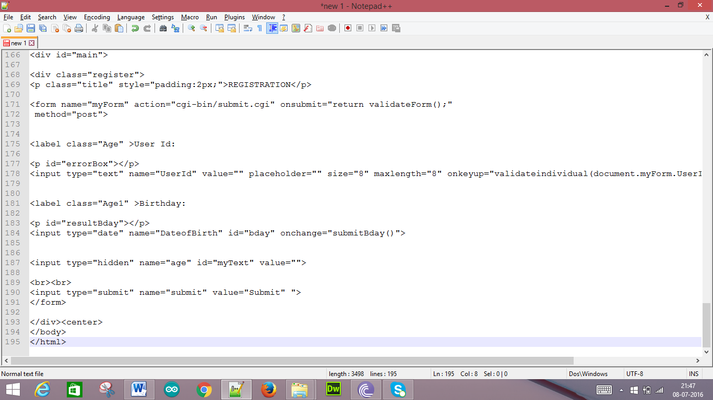

Save the above HTML file as **mysubmit.html**

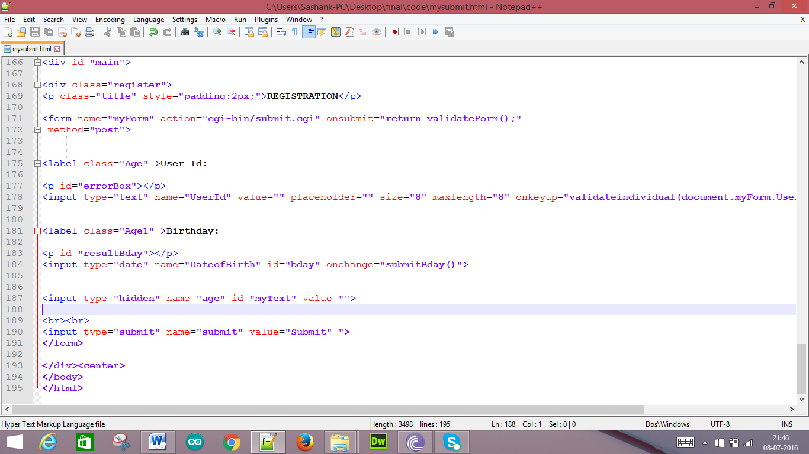

Below is the CSS code for the above designed page

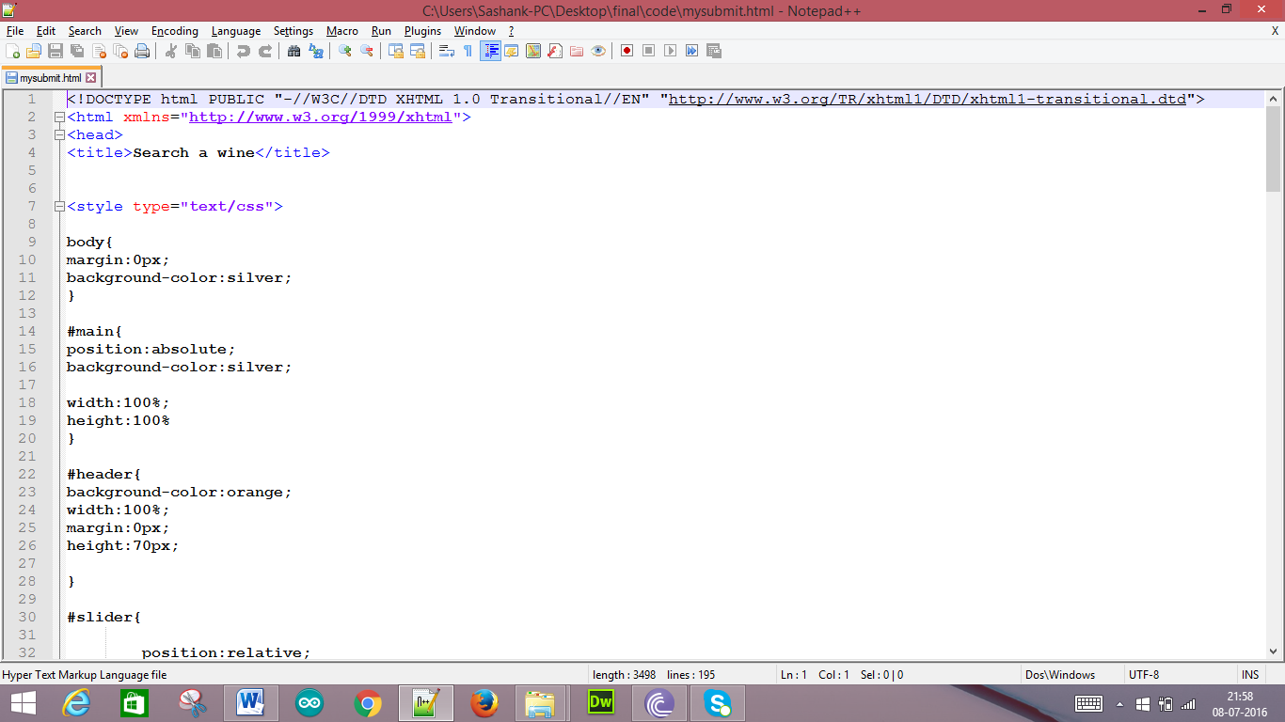

This is tag used for User Id text field

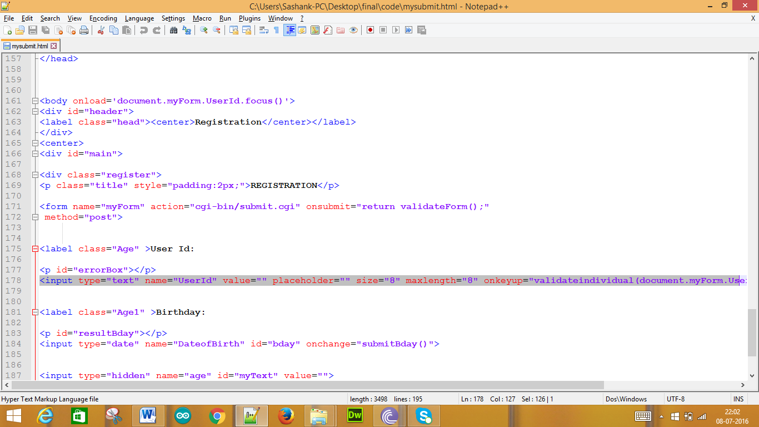

This is tag used for Birthday field

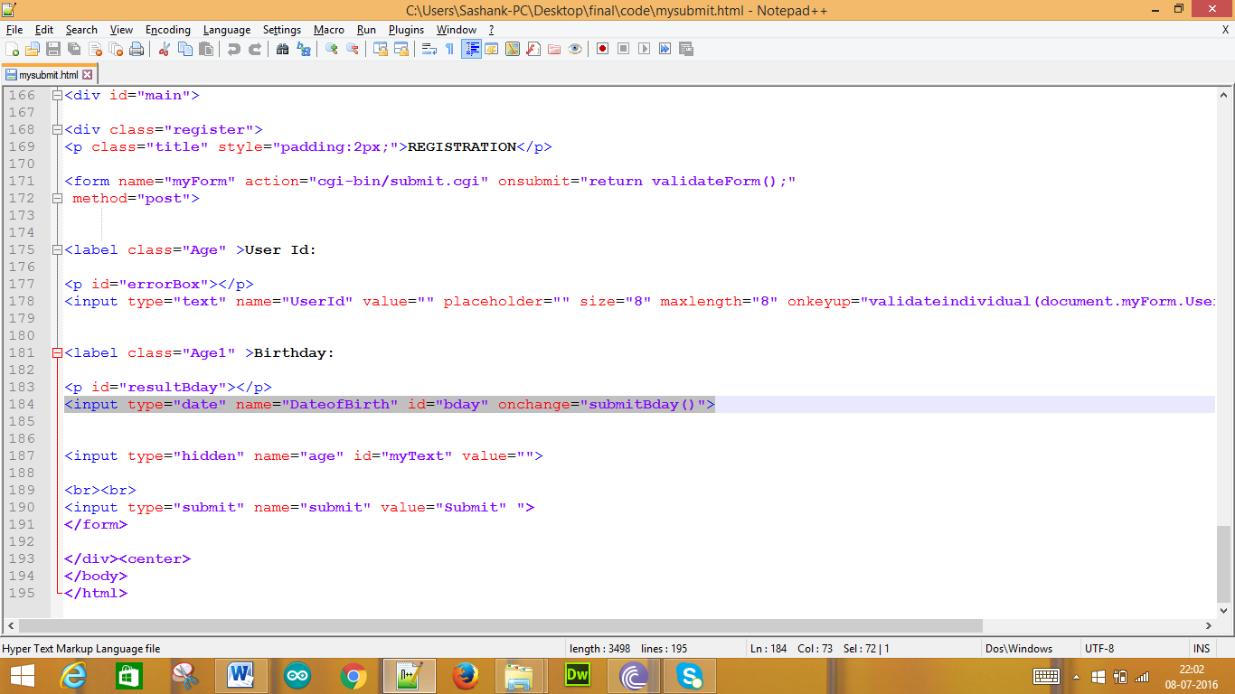

This is tag used for submit button

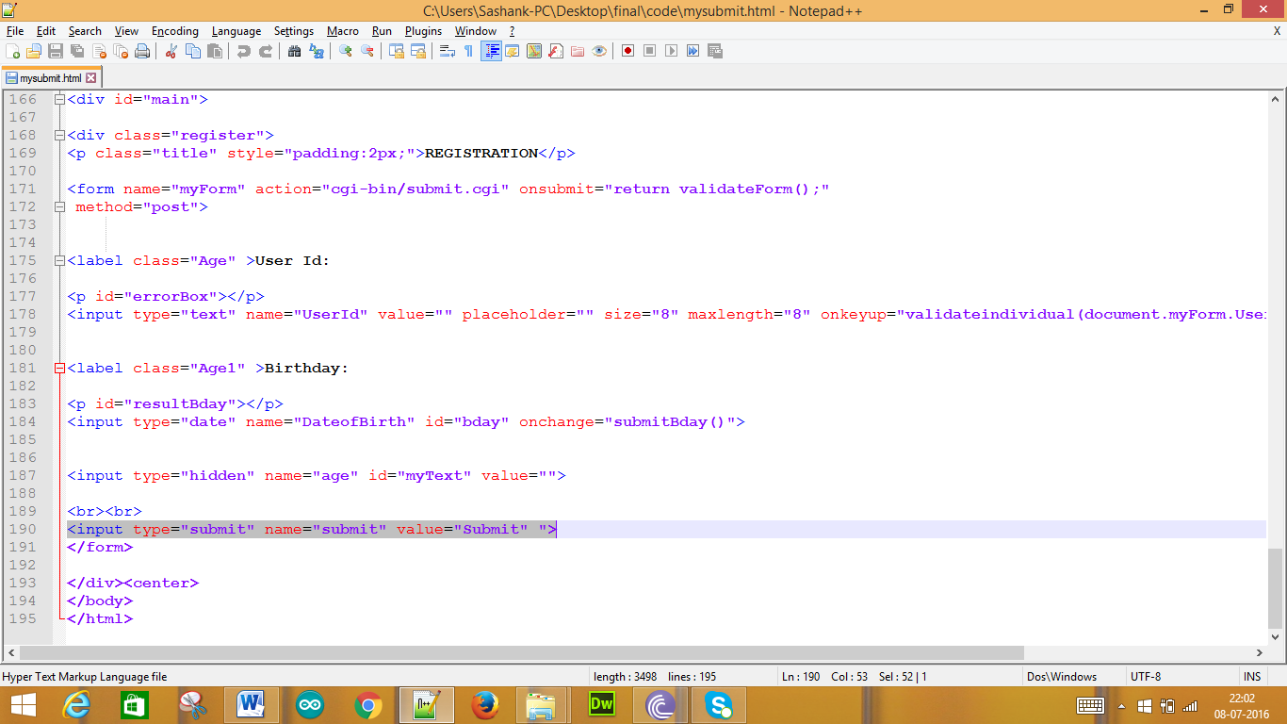

Now we need to connect to the server

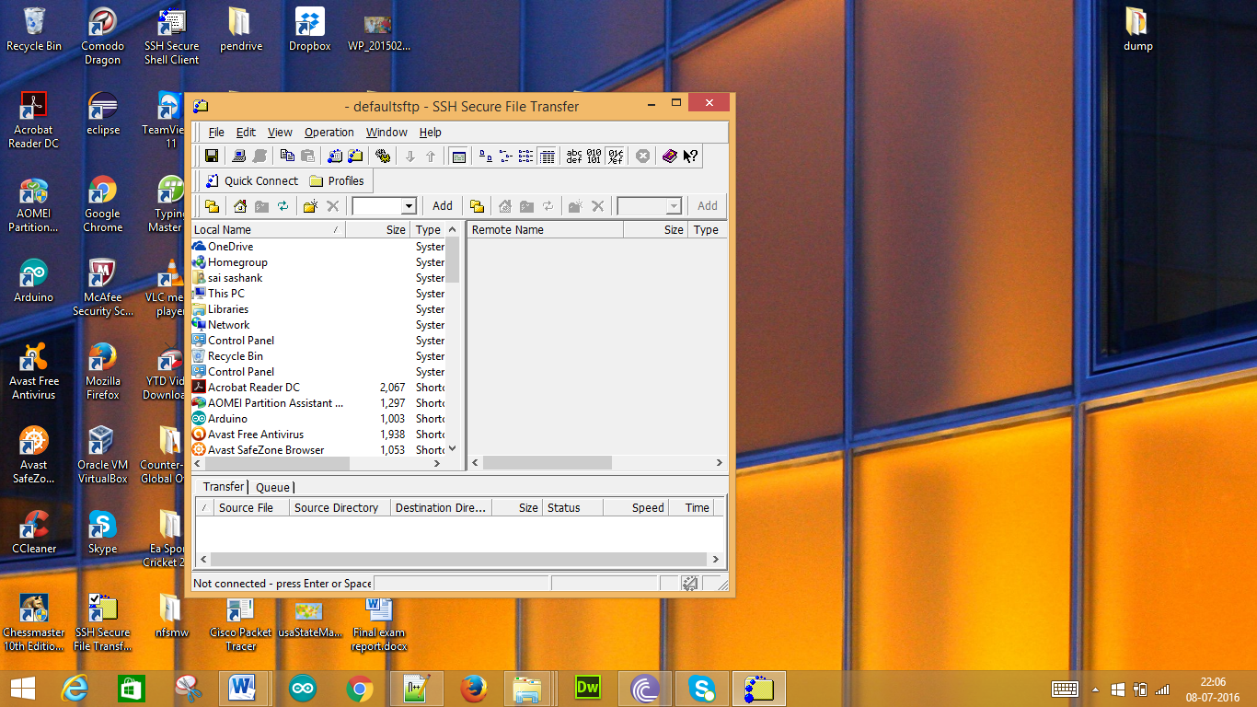

We need to click “Quick Connect” we get as follows:

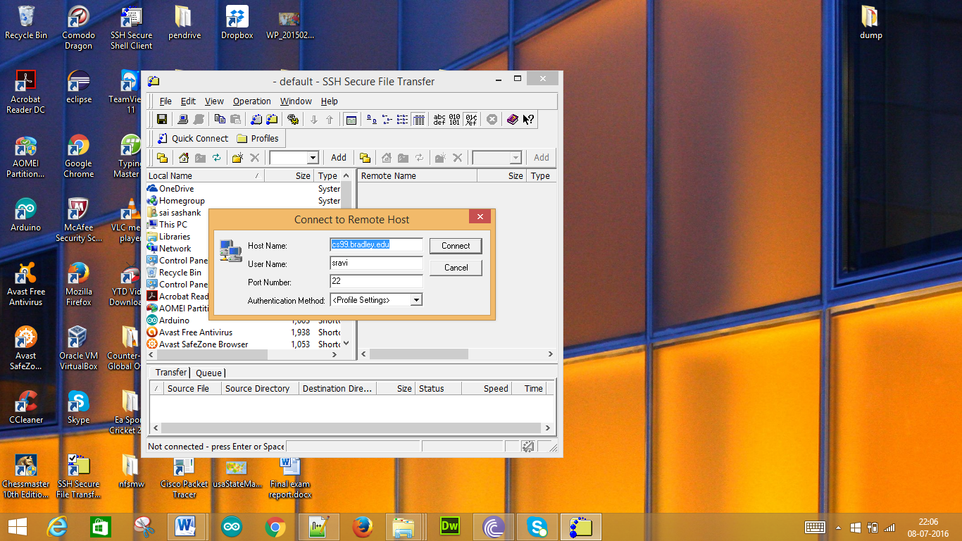

When we click connect we need to enter the password and we get as follows:

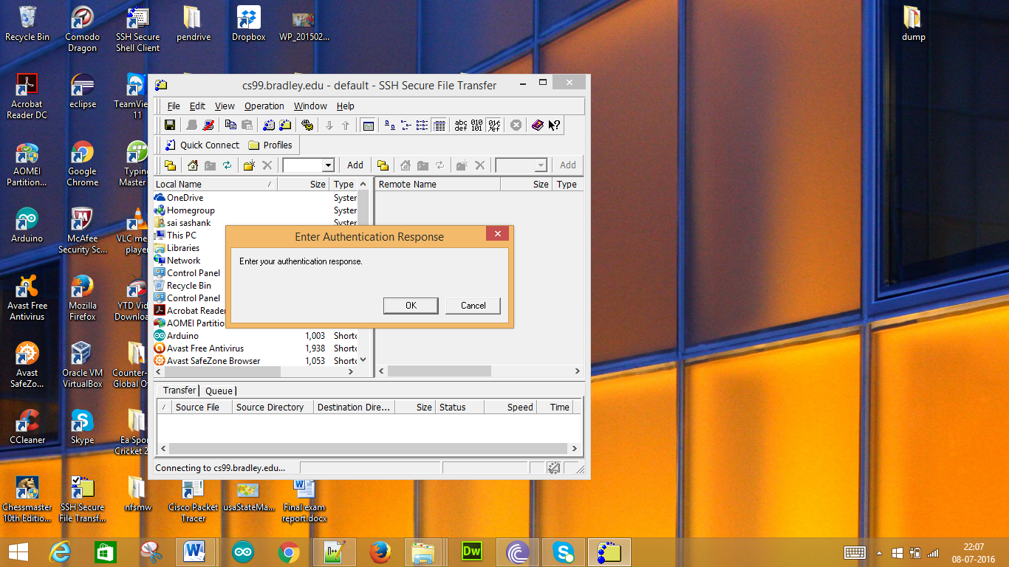

When we click OK we get the following

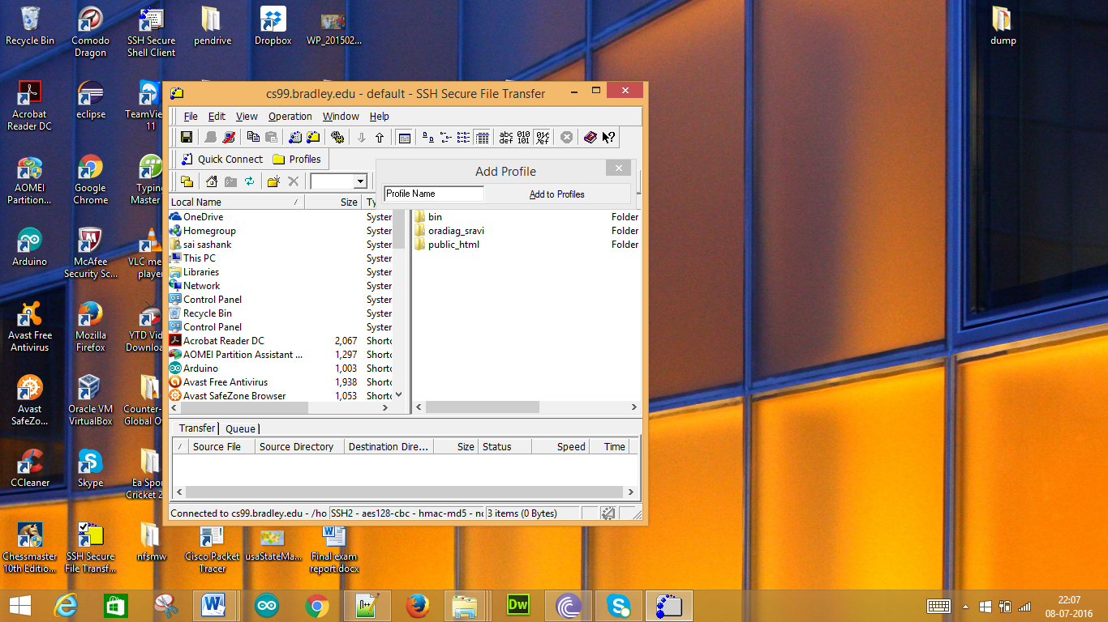

In the public_html folder we copy the mysubmit.html file

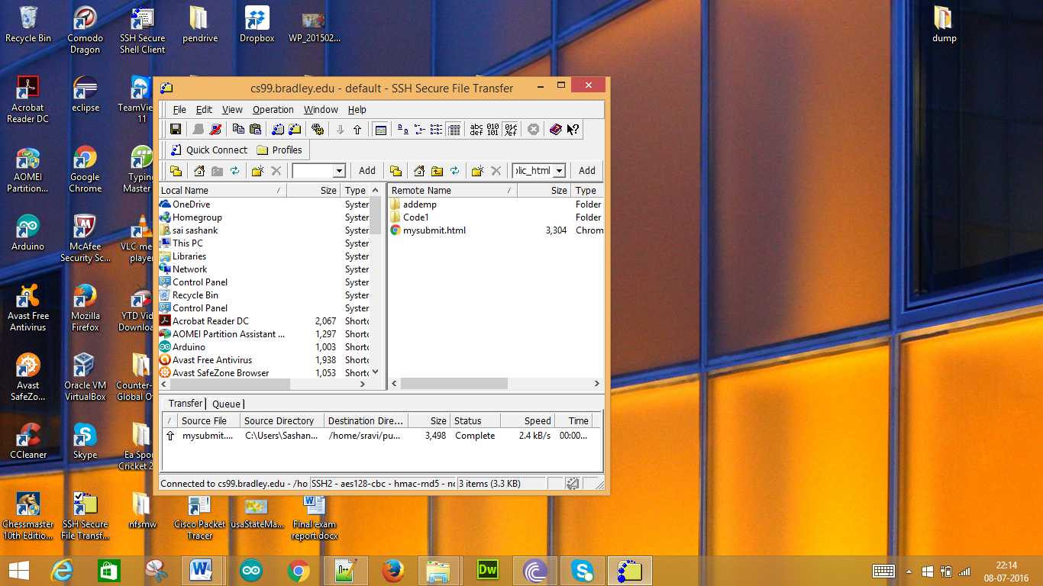

Now we need to run the file on server with this URL: <http://cs99.bradley.edu/~sravi/mysubmit.html> .

Now we get the following page

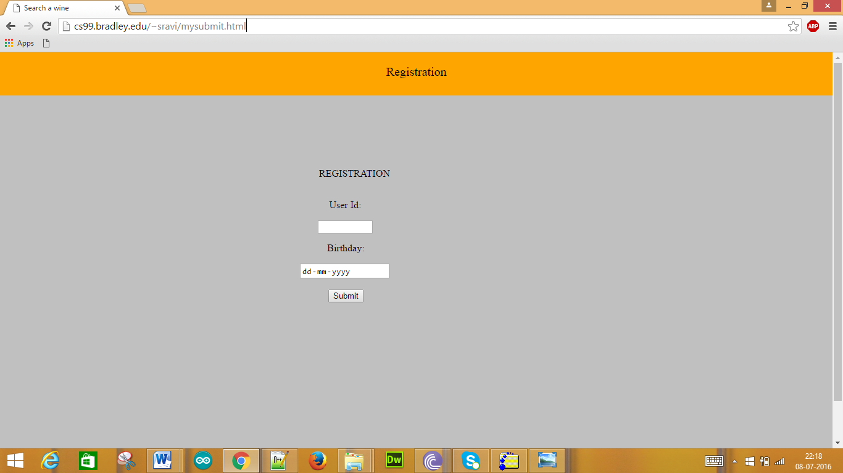

The above page consists of the user id text field and date field for the Birthday and a submit button.

1. Write the Perl program submit.cgi that returns a HTML web page with an acknowledge message with the user ID and birthday received. If the person’s age is less than 21, than the message should also say “You can’t drink alcohol.”

Sol:

Now we need to create a CGI file in order to take the inputs in the form. The file is as follows:

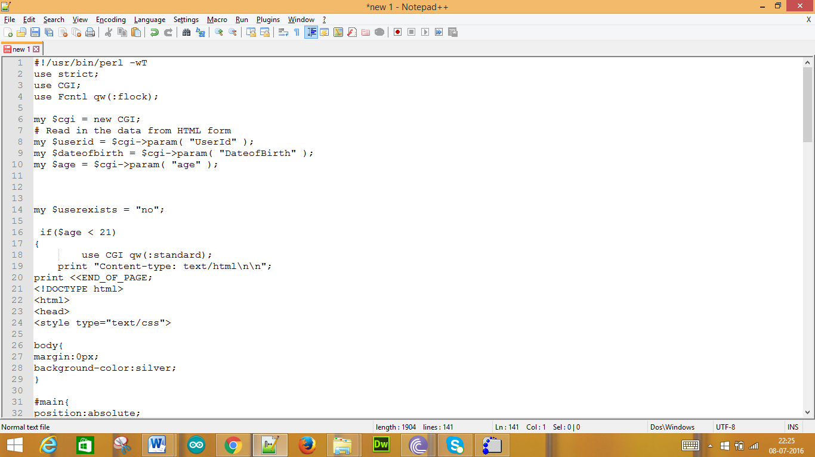

We save this file as submit.cgi

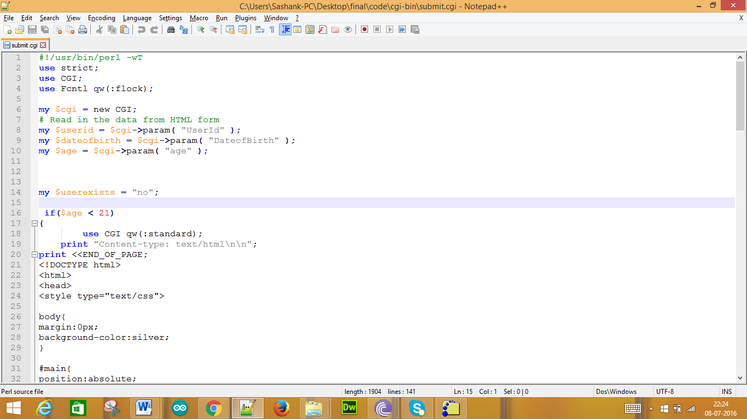

Below is the code for delivering the message “You can’t drink alcohol”.

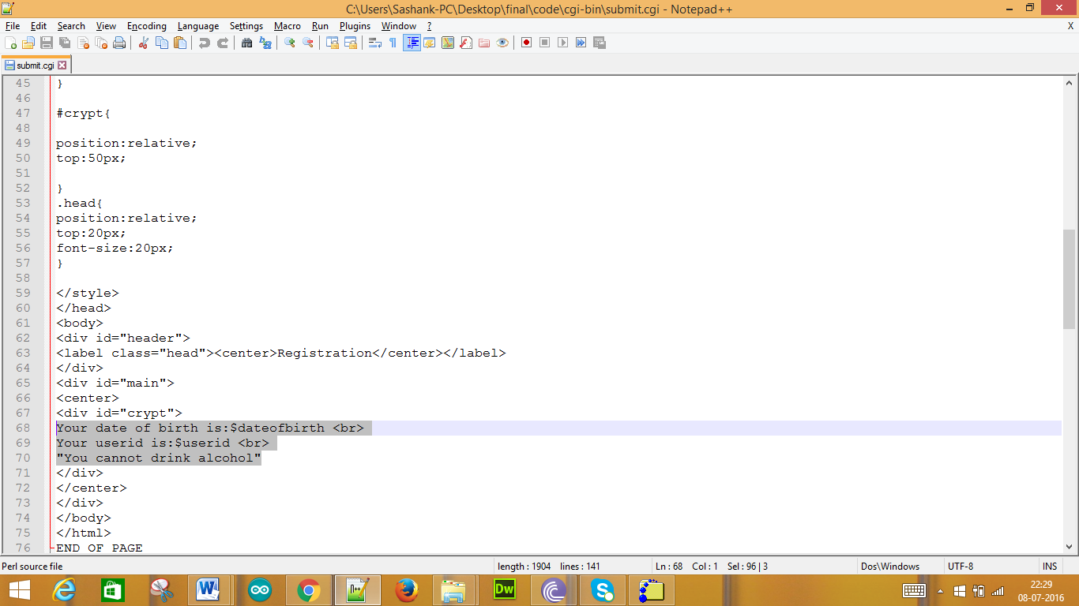

Now we upload the submit.cgi file on to the server in the folder cgi-bin

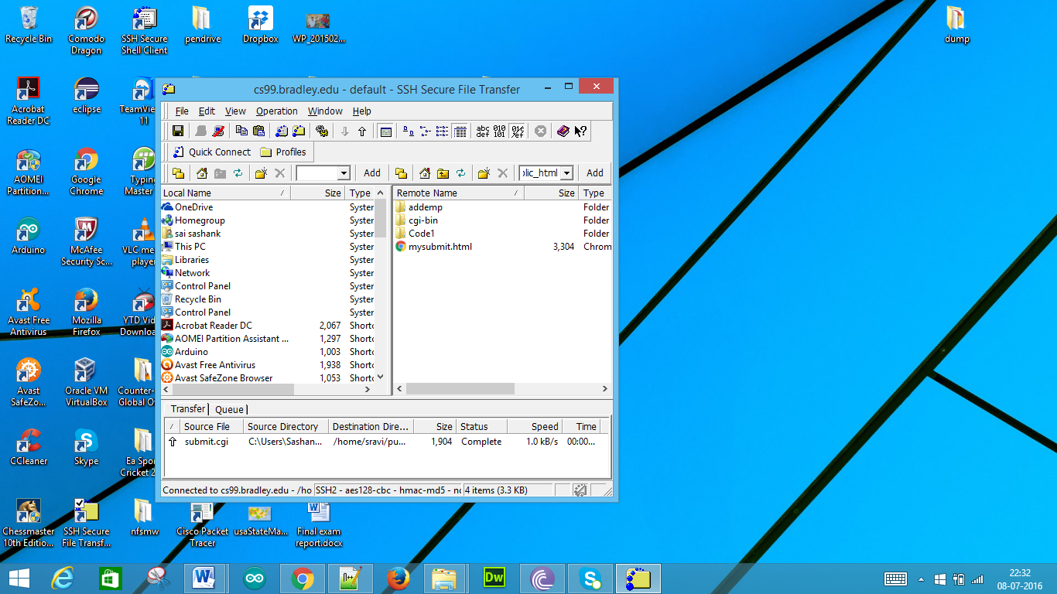

In the cgi-bin we have the following

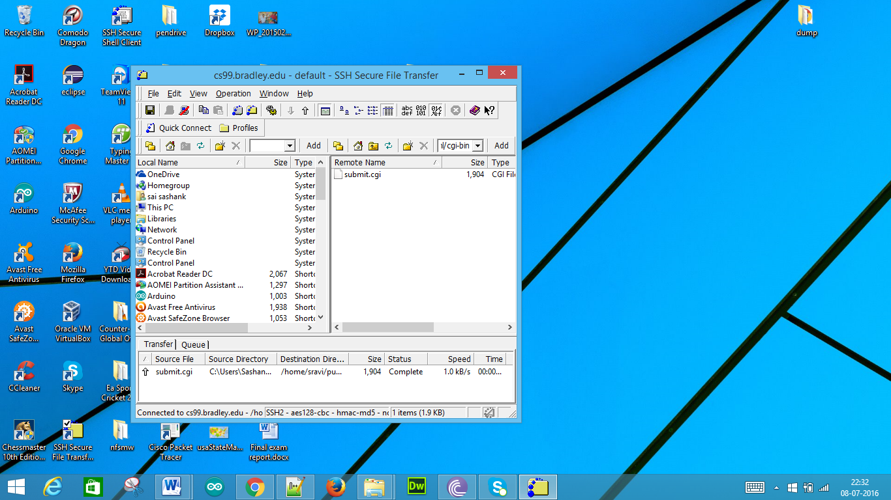

1. Test and run the above web page and Perl program with both age less than 21 and the age greater than 21; submit the source code and screen shots of the run results.

Sol:

With the URL which is mentioned above we get the following page

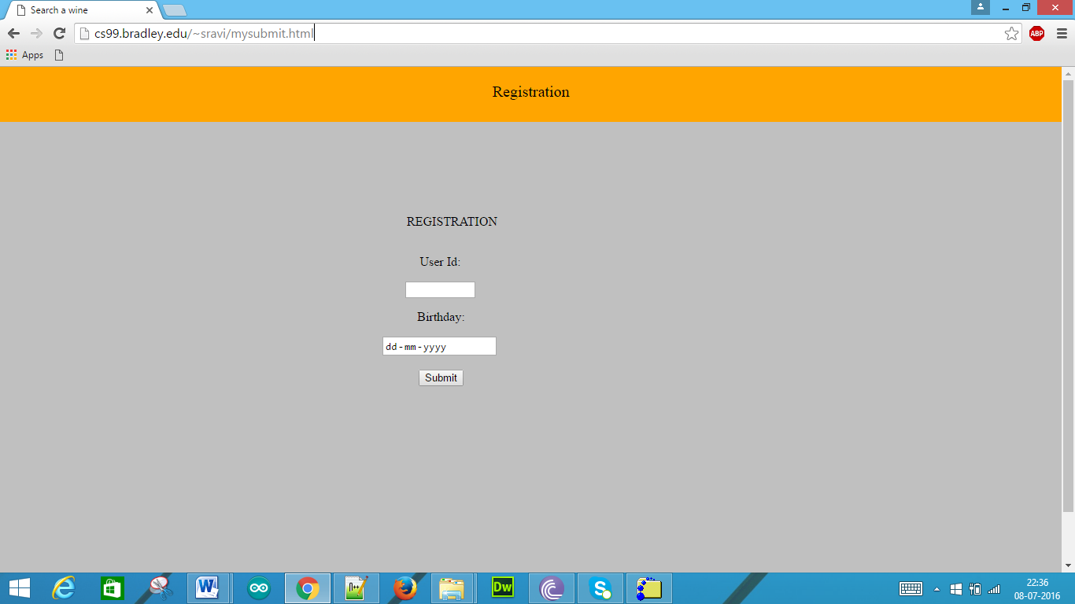

When we enter the user id and the birthday it is as follows:

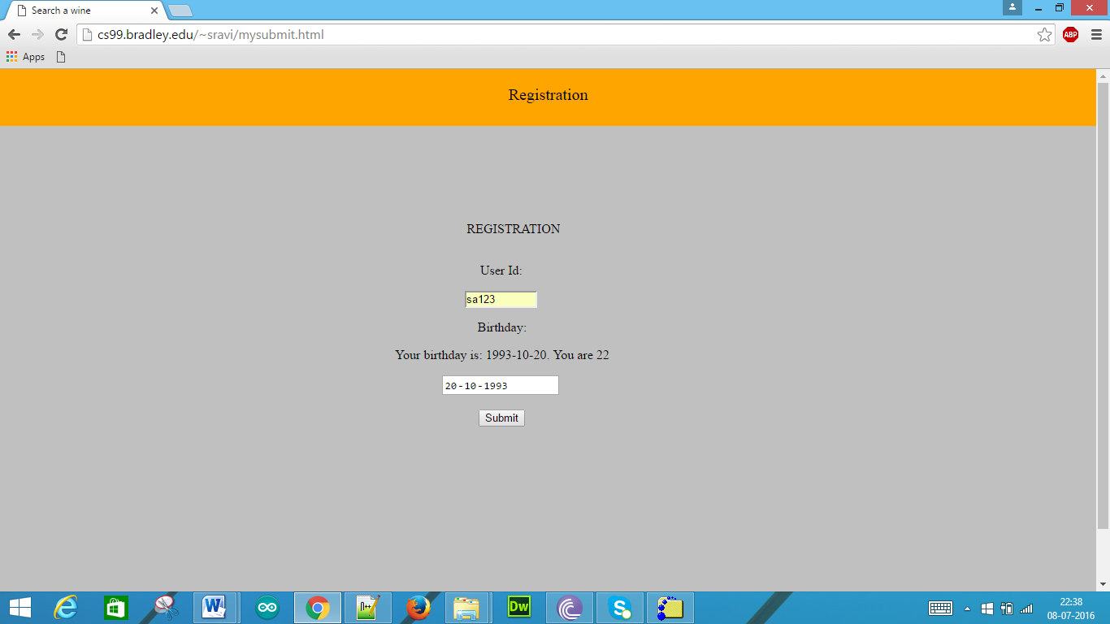

When we click submit button we get the following

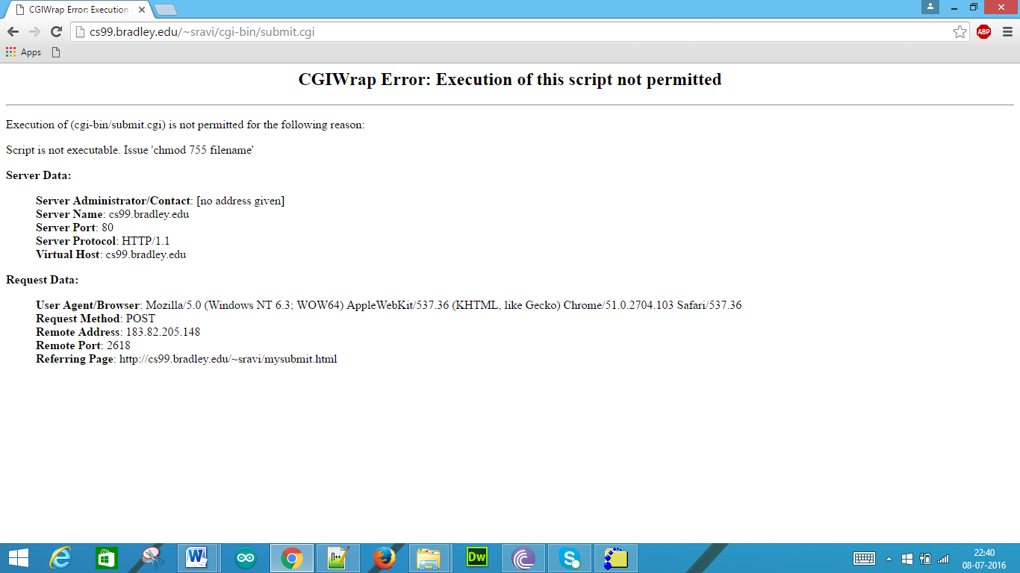

For this we need to do as such

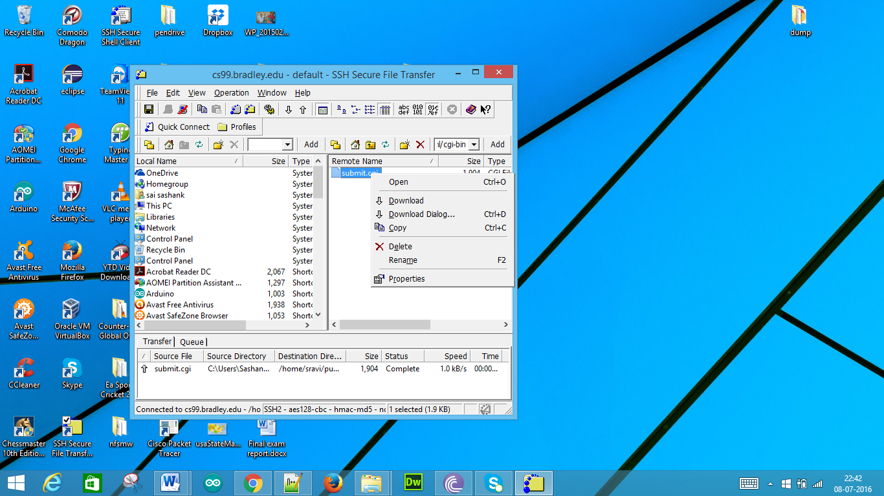

Now we click the properties we get

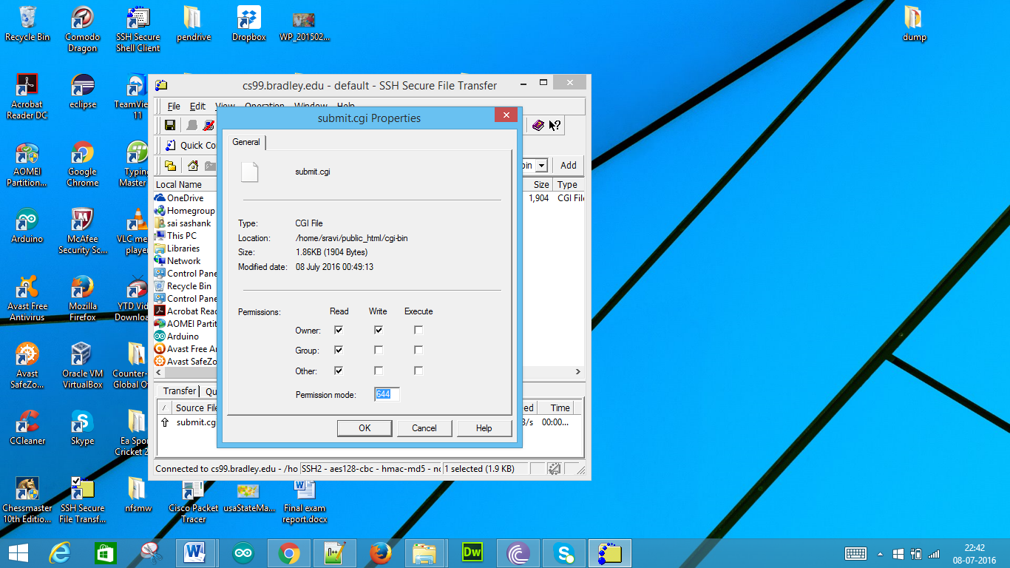

We need to check all the execute columns and click ok

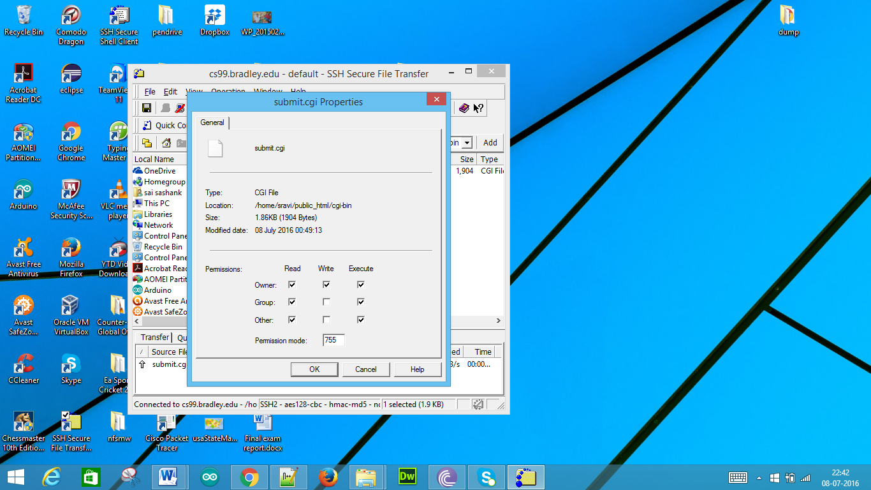

When we again go to the URL and enter the same credentials and click submit

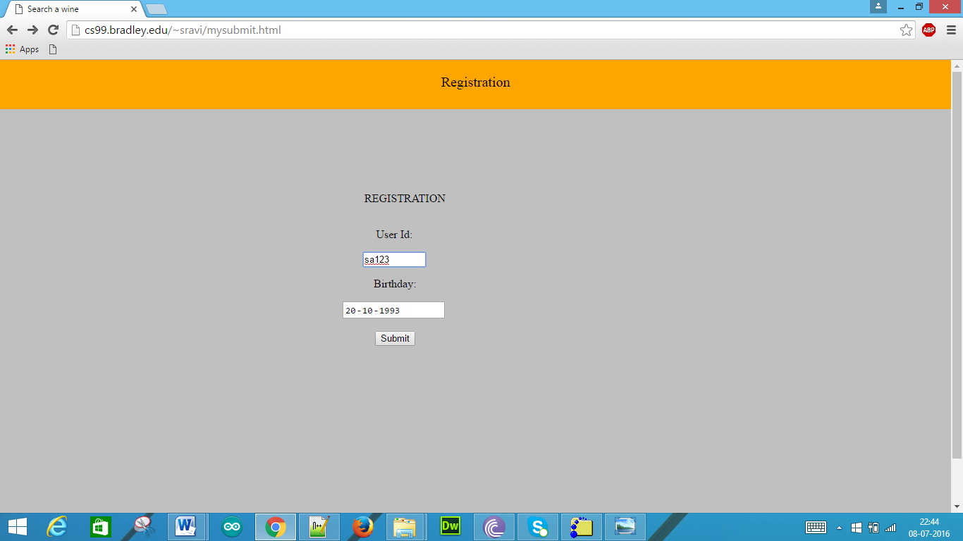

As the age is above 21 i.e. greater than 21 when we click the submit button we get the details of registration and a message that “You can drink alcohol”.

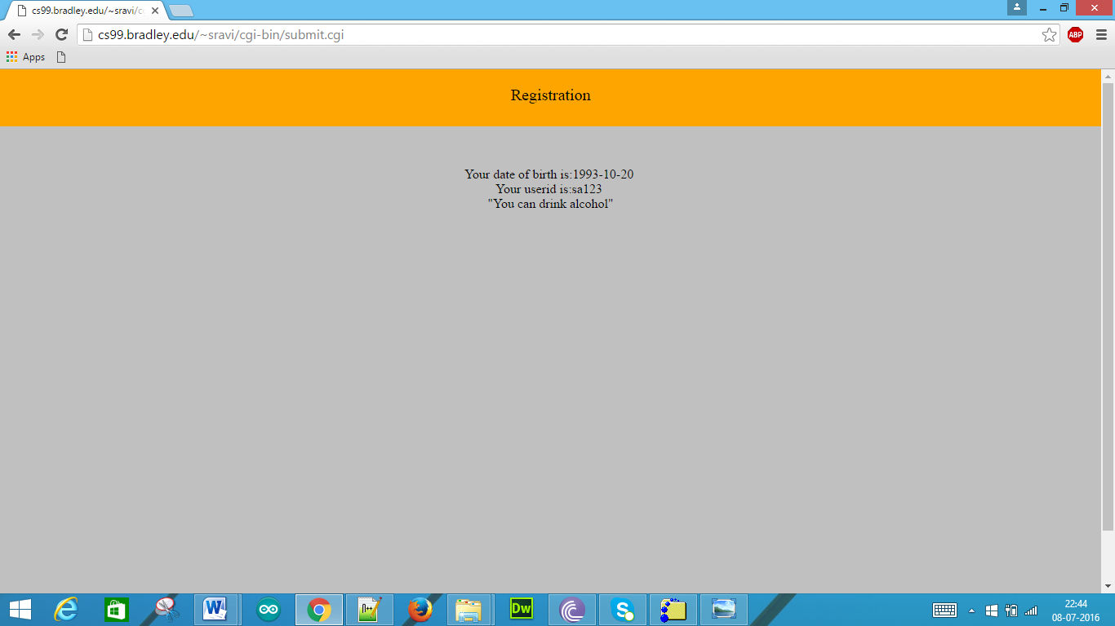

If we enter the date of birth below 21 i.e. less than 21, as below

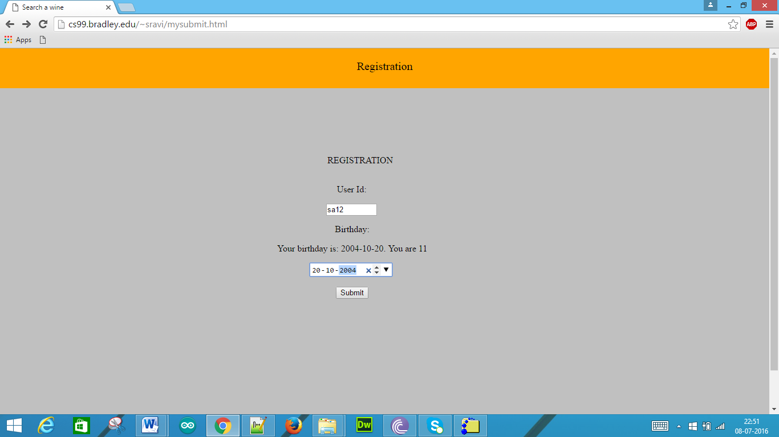

When we click the submit button we get “You cannot drink alcohol”.

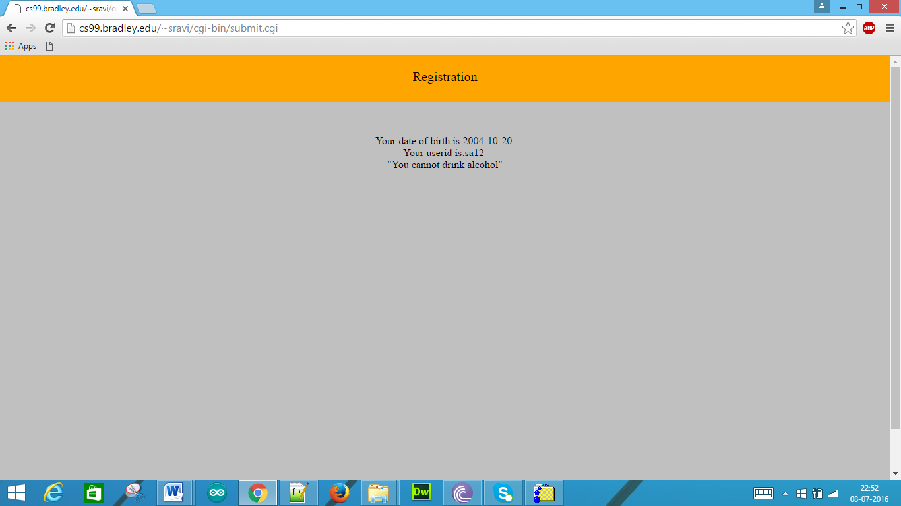

3. (25 pts) Web programming using JavaScript

1. Add the JavaScript on the above HTML5 web page to validate the user ID (make sure the user ID starts with two letters plus 6 digits) and the date (make sure the date is not empty) using the DOM innerHTML to print out the error message.

Sol:

The above created HTML file is as follows:

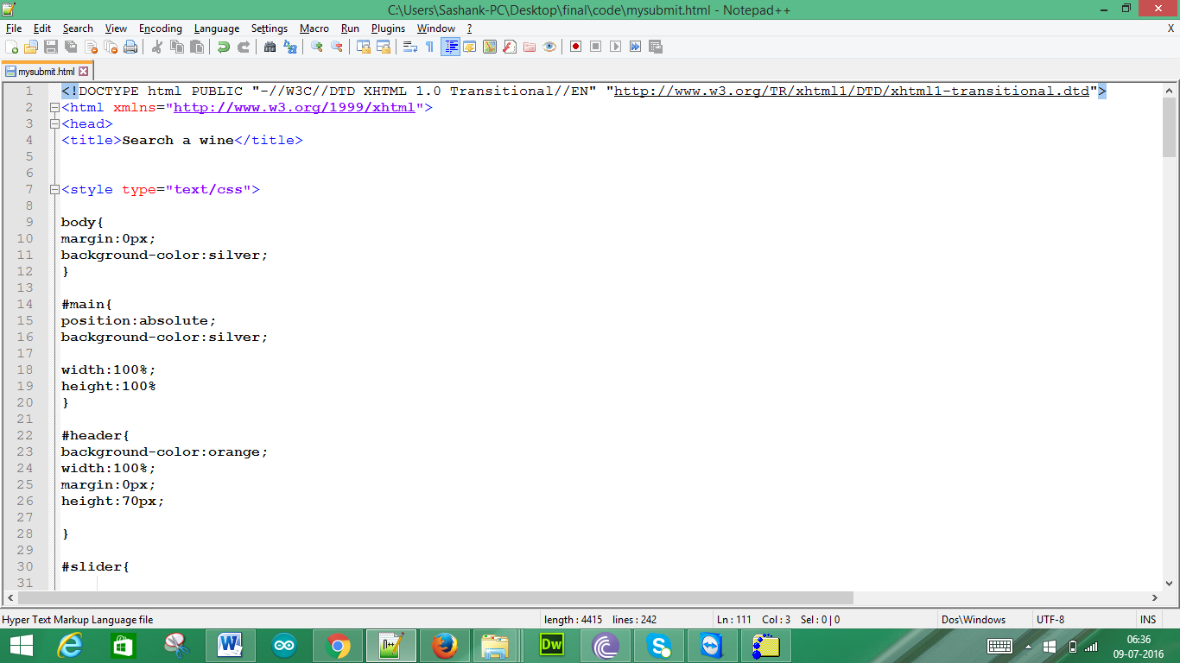

Below is the code for the User Id validation

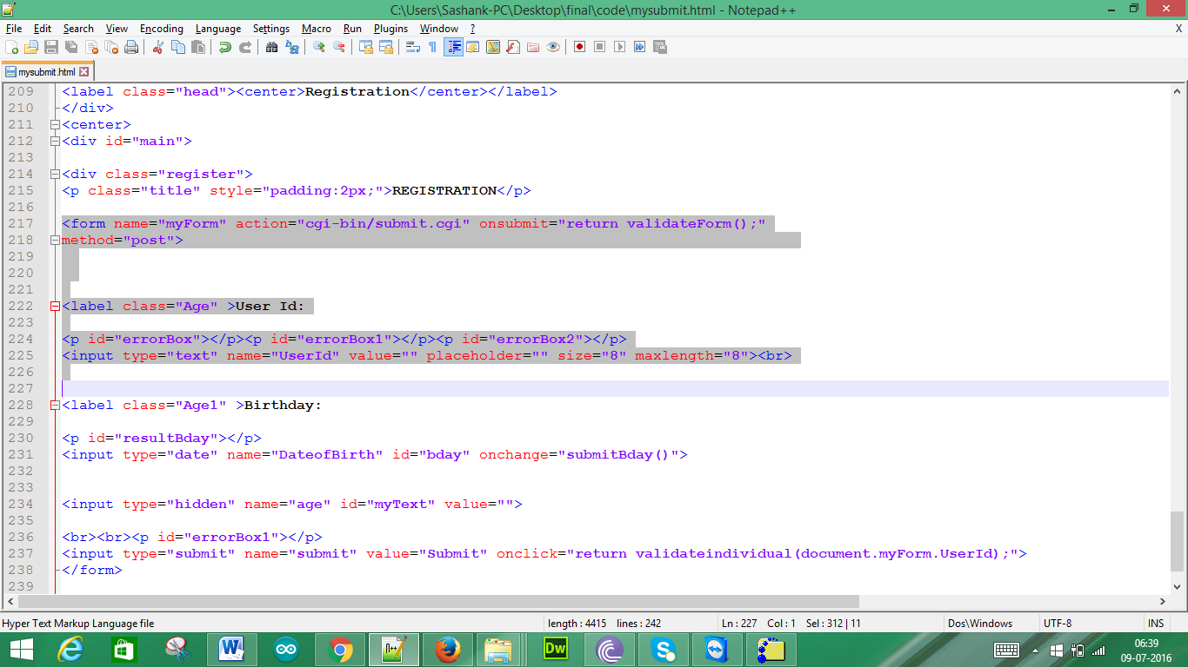

This is the code for obtaining the message if we do not enter the User Id and click submit button

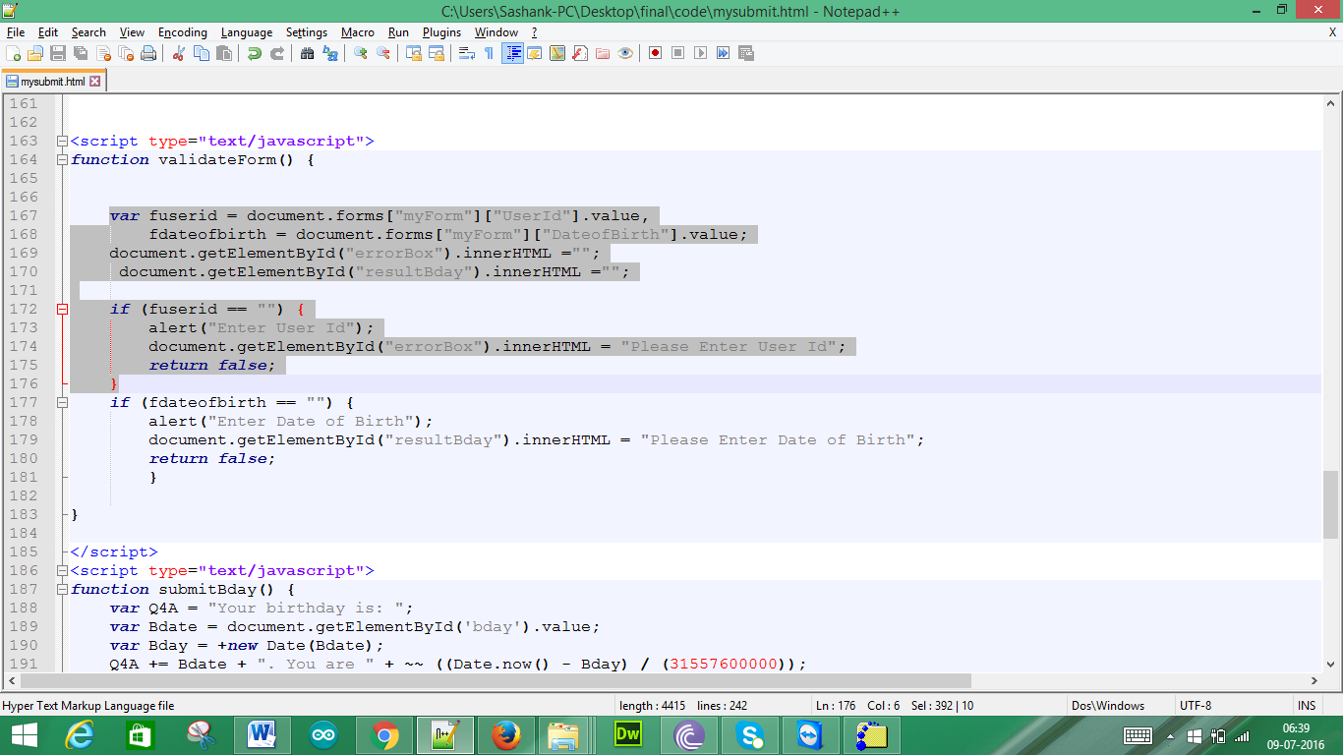

This is the code for obtaining the message if we enter the User Id not as per requirement and click submit button

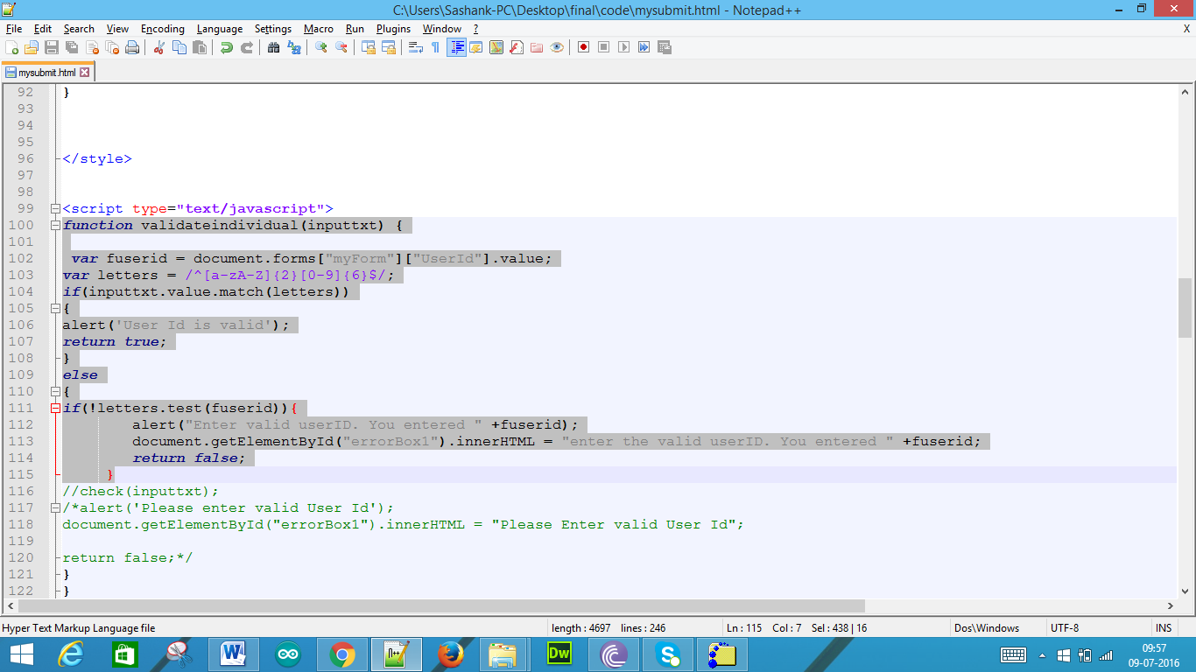

This is the code to print out the error message using the DOM innerHTML, if we do not enter Date of Birth and click submit button

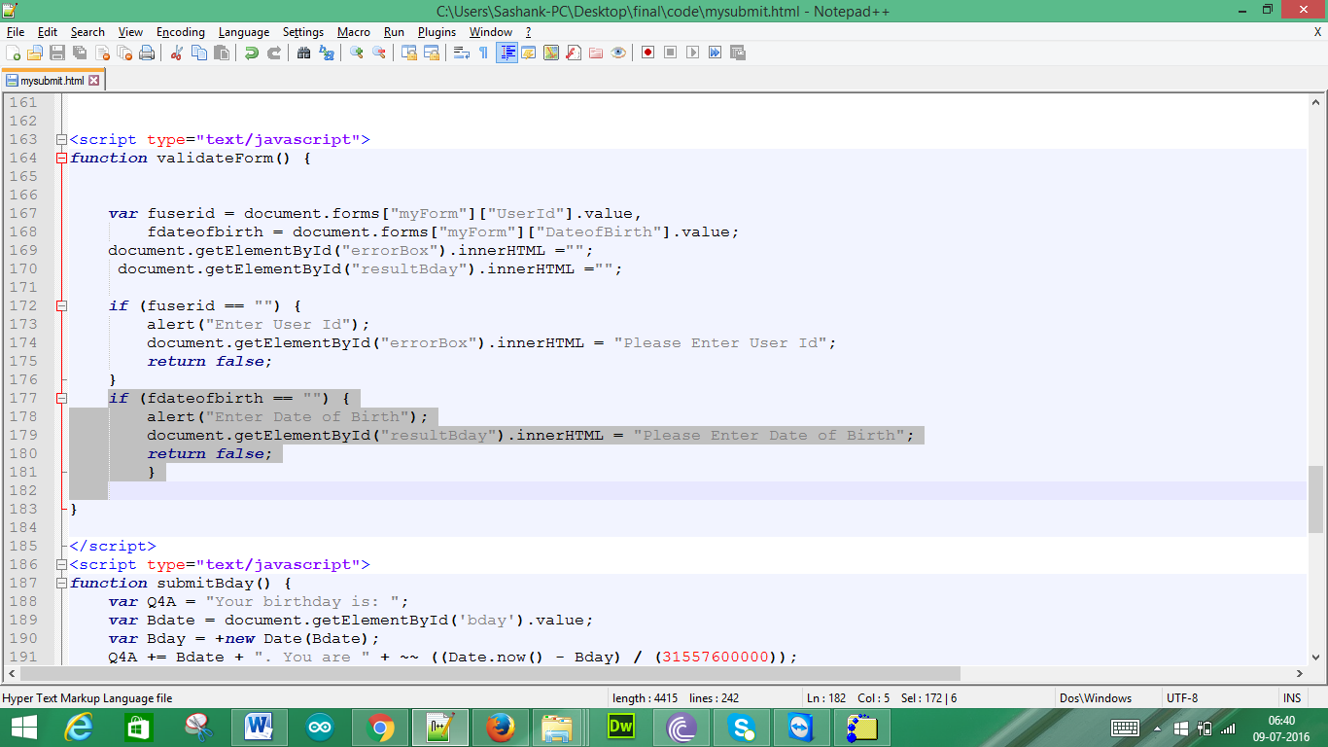

1. Add a JavaScript’s built-in String object to display the letter part and the digit part in the user ID in the error message if the user ID is invalid.

Sol:

The following is the mysubmit.html

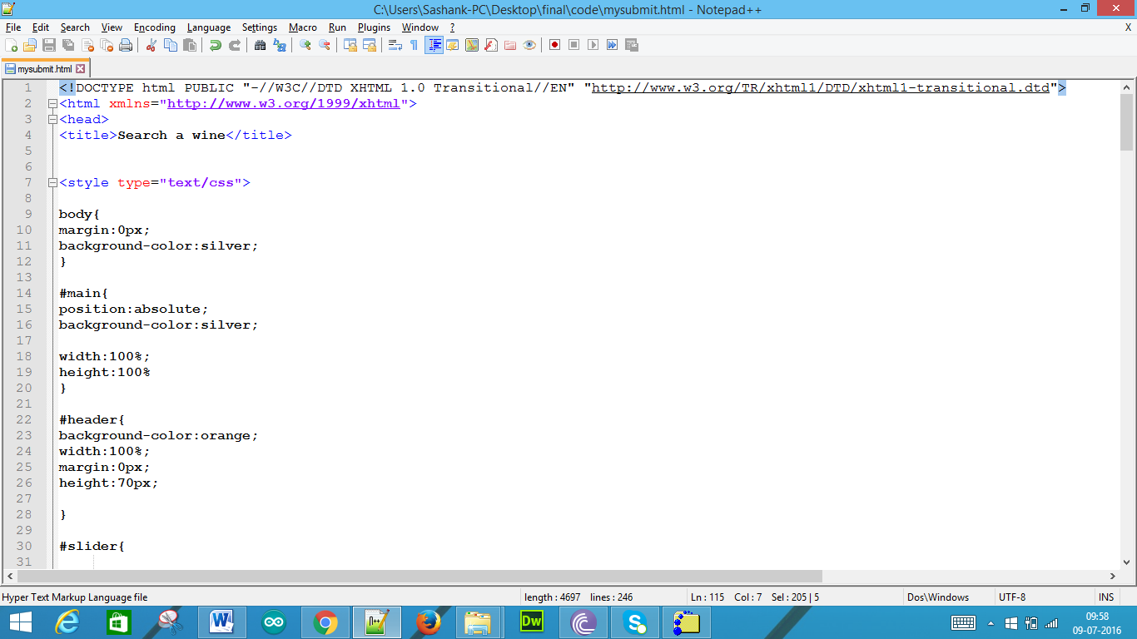

In this we use the javascript as such

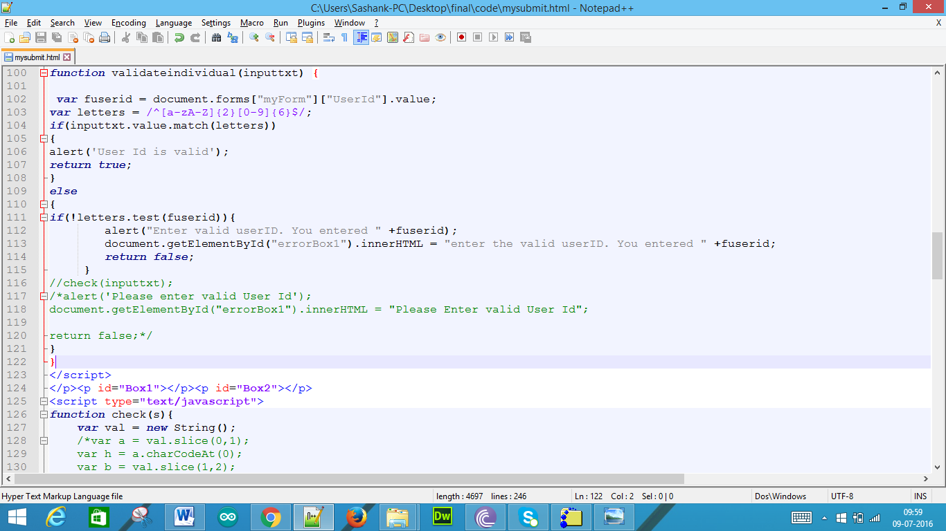

1. Test and run the above web page with the JavaScript; submit the source code and screen shots of the run results with both invalid and valid user inputs.

Sol:

We get the following page by using this URL: <http://cs99.bradley.edu/~sravi/mysubmit.html>.

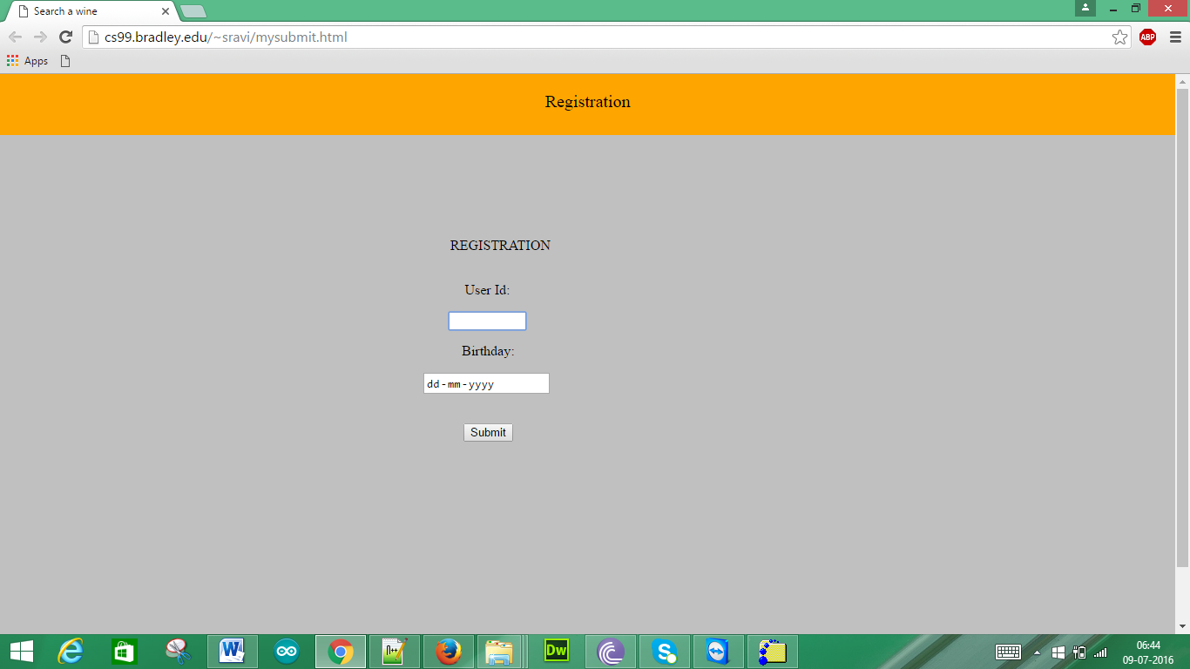

When we click the submit button we get the following pop up

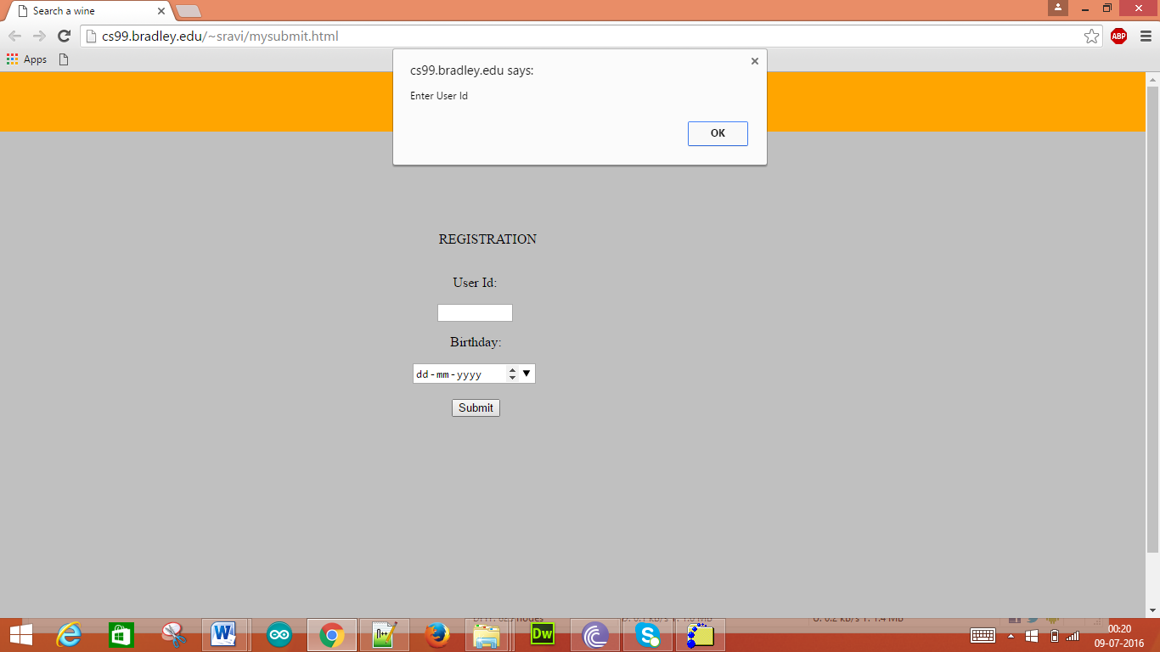

When we click OK we get the following

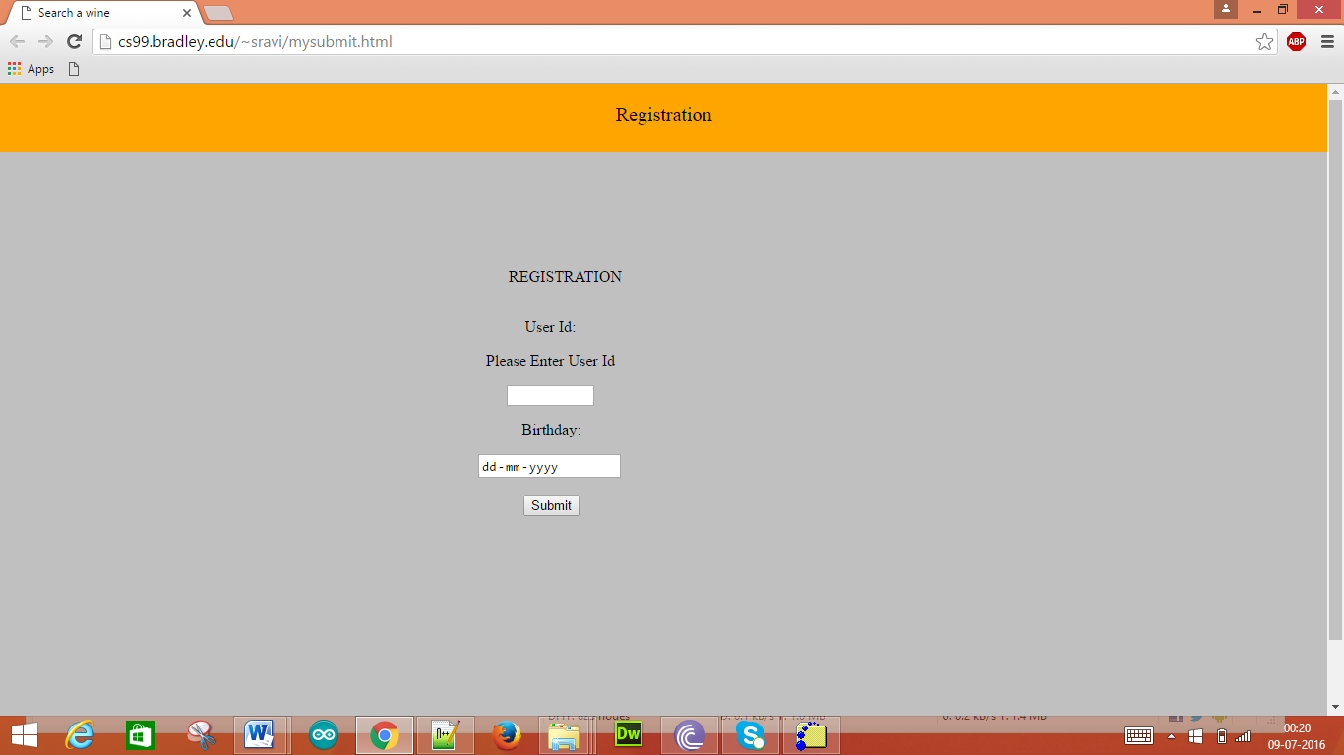

When we enter only the User Id

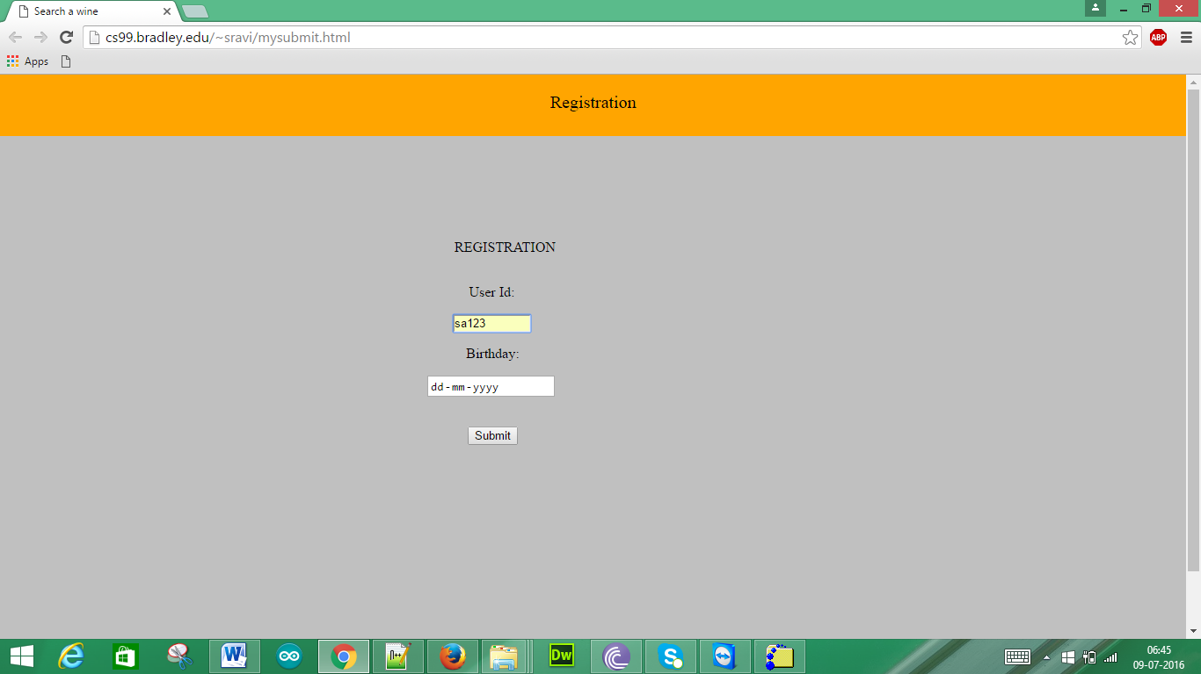

When we click submit, we get the following pop up:

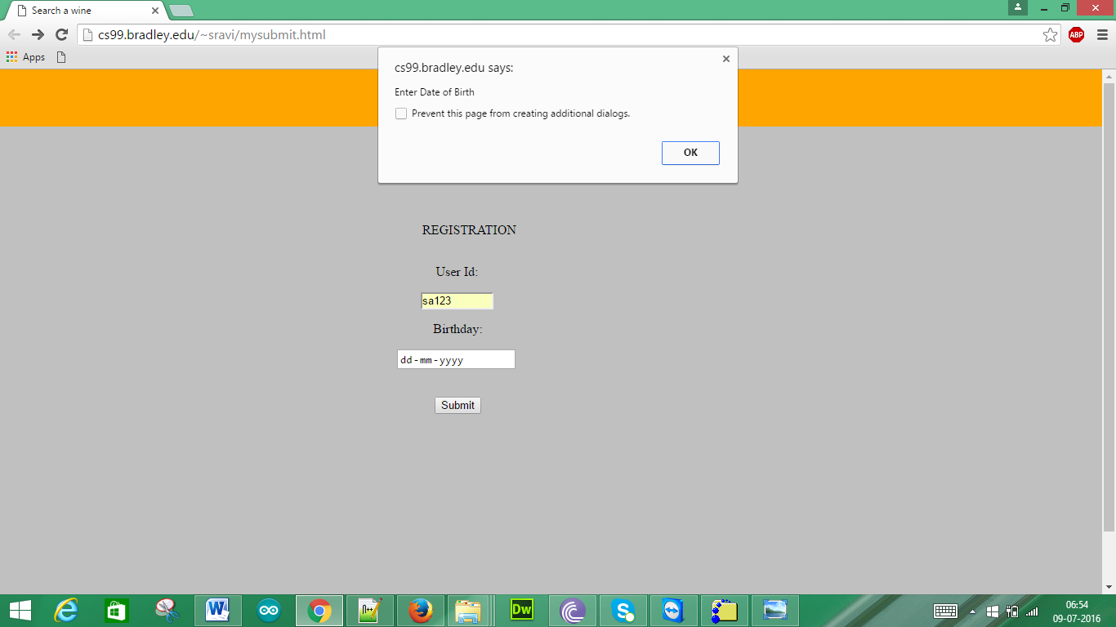

When we click OK then we get the following:

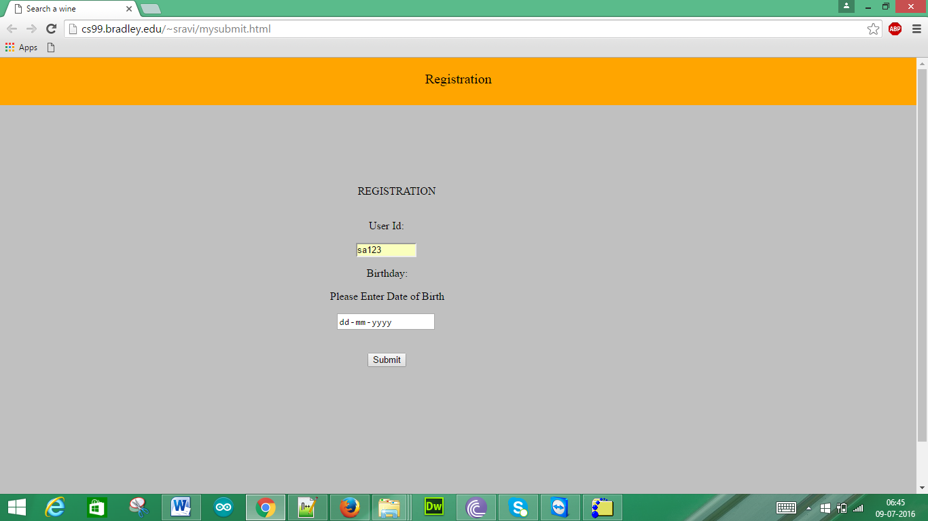

When we enter both the fields as below

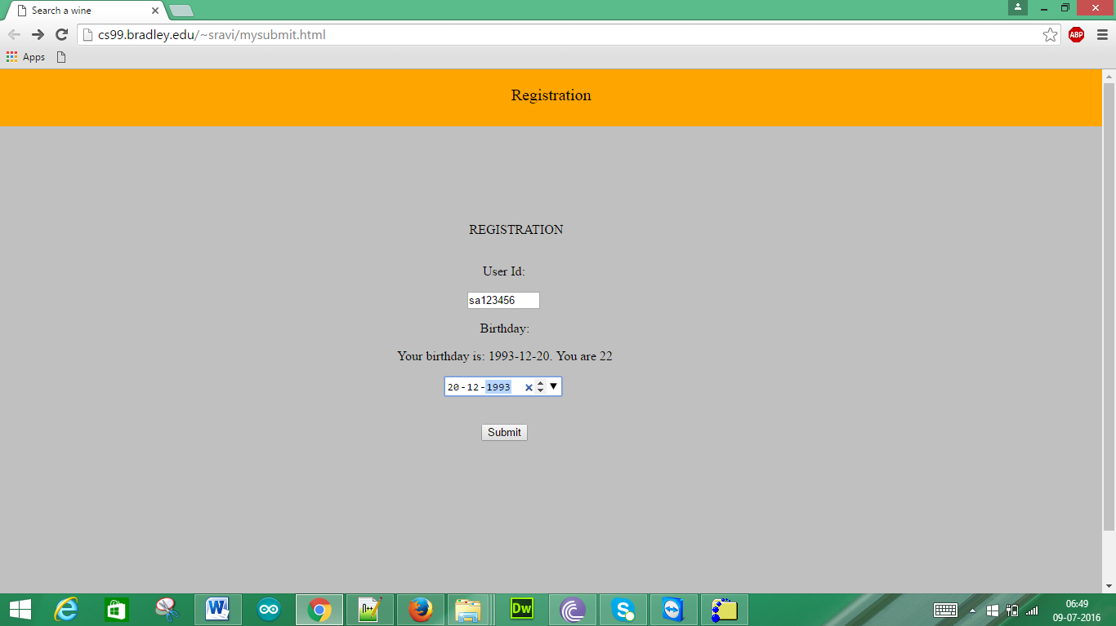

When we click submit we get following pop up

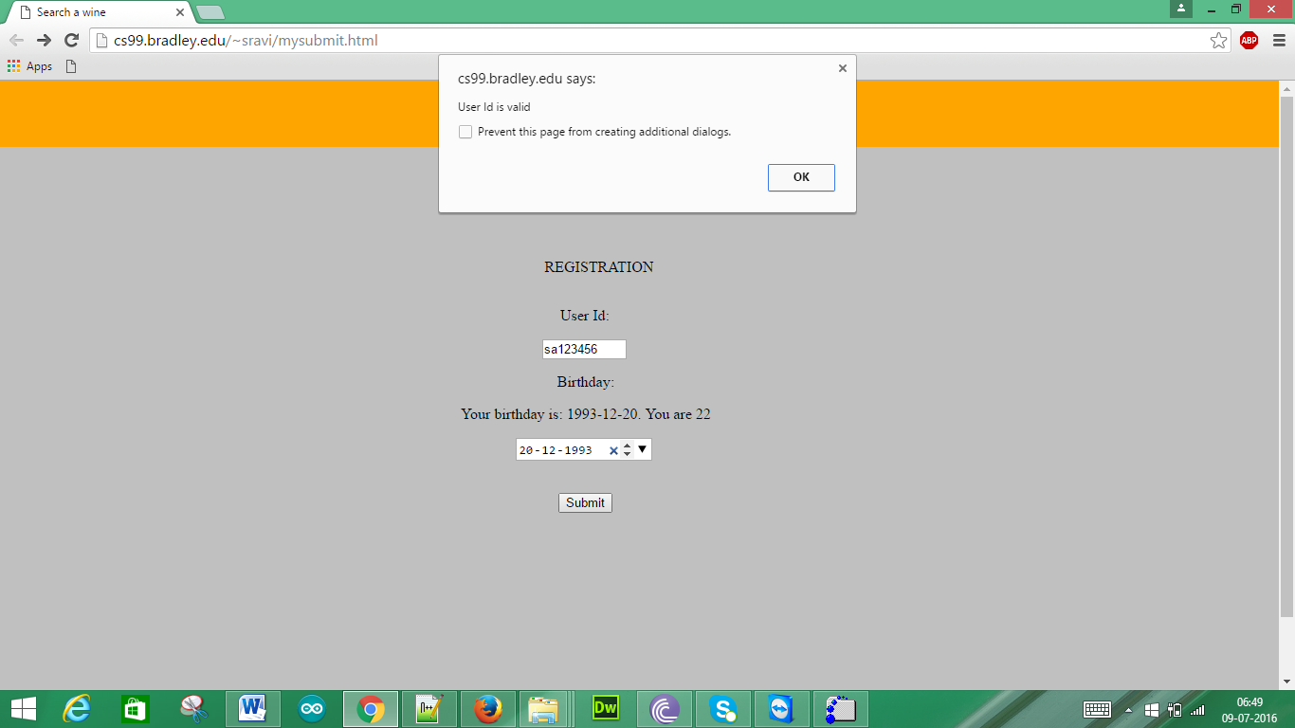

When we click OK we get the following:

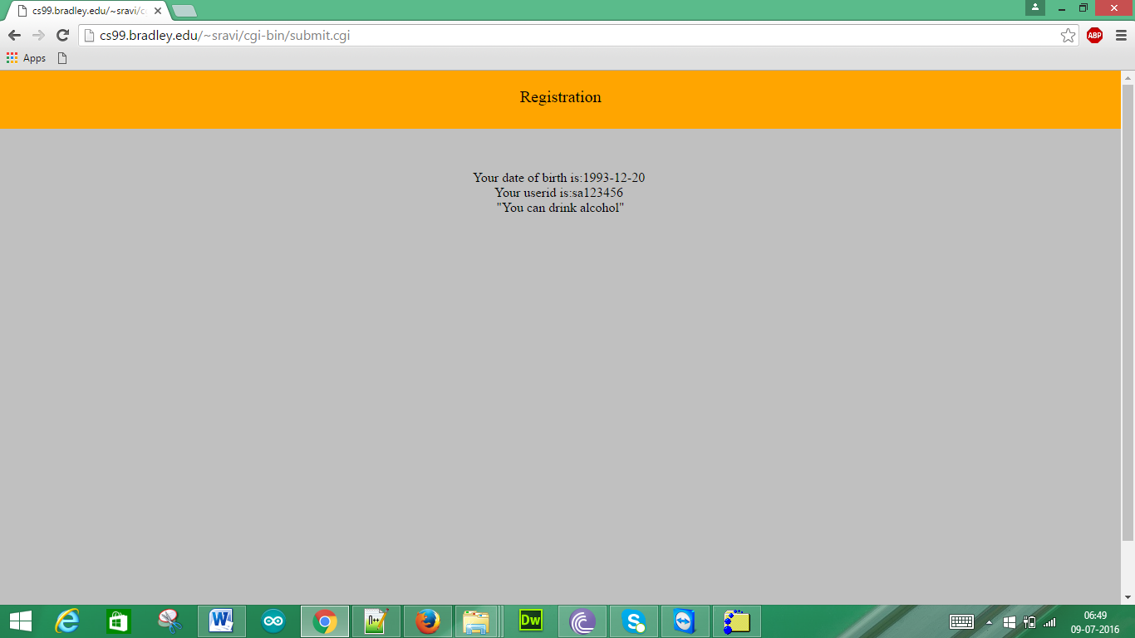

When we give the following inputs

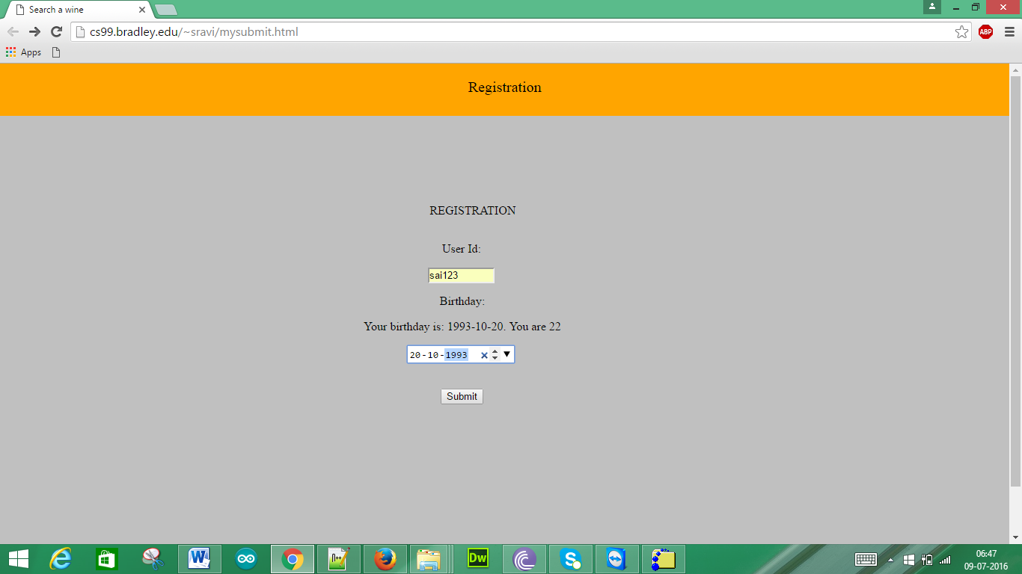

When we click submit we get the following pop up

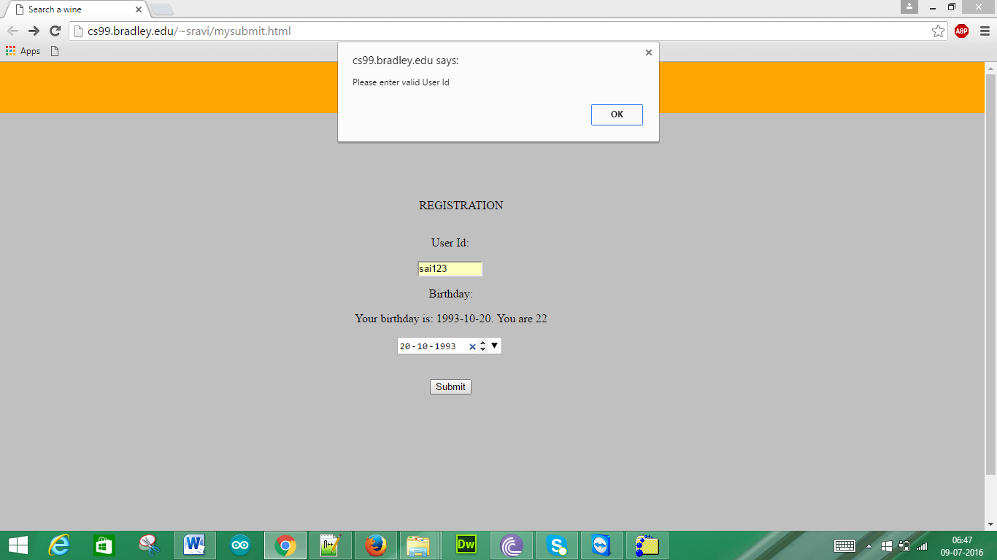

When we click OK we get

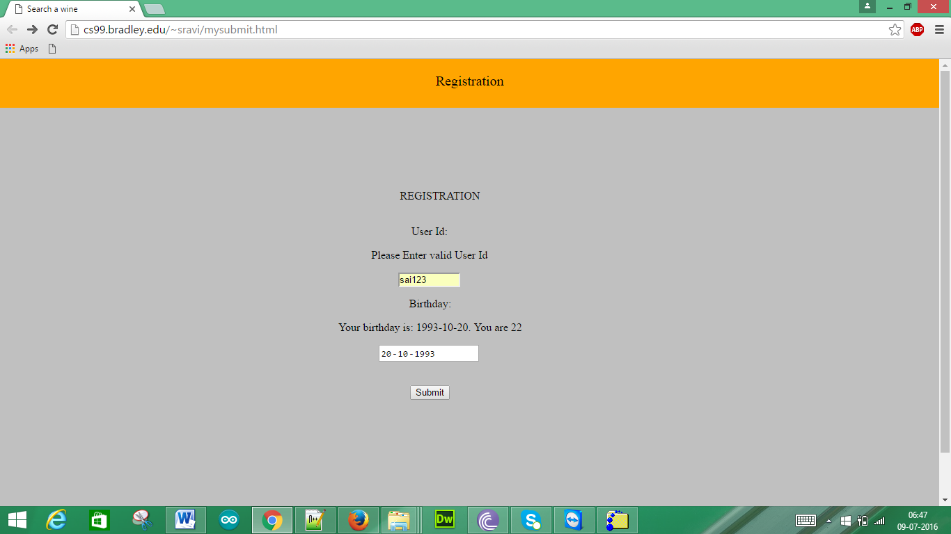

When we give starting of User Id with number as below:

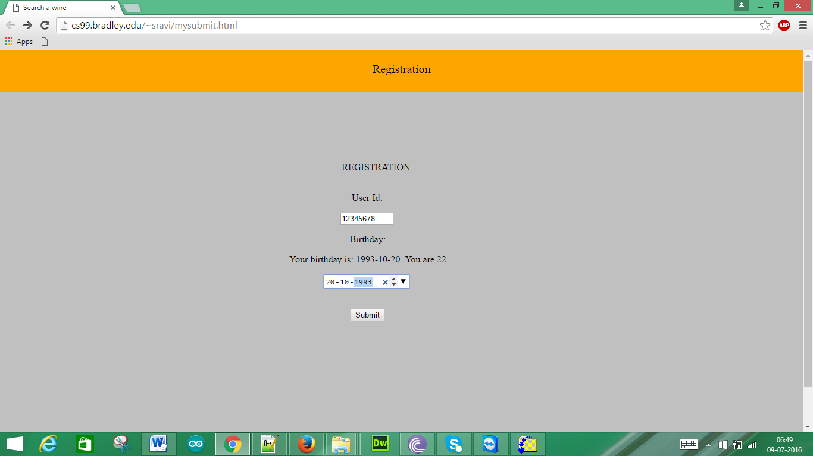

When we click submit we get the following pop up

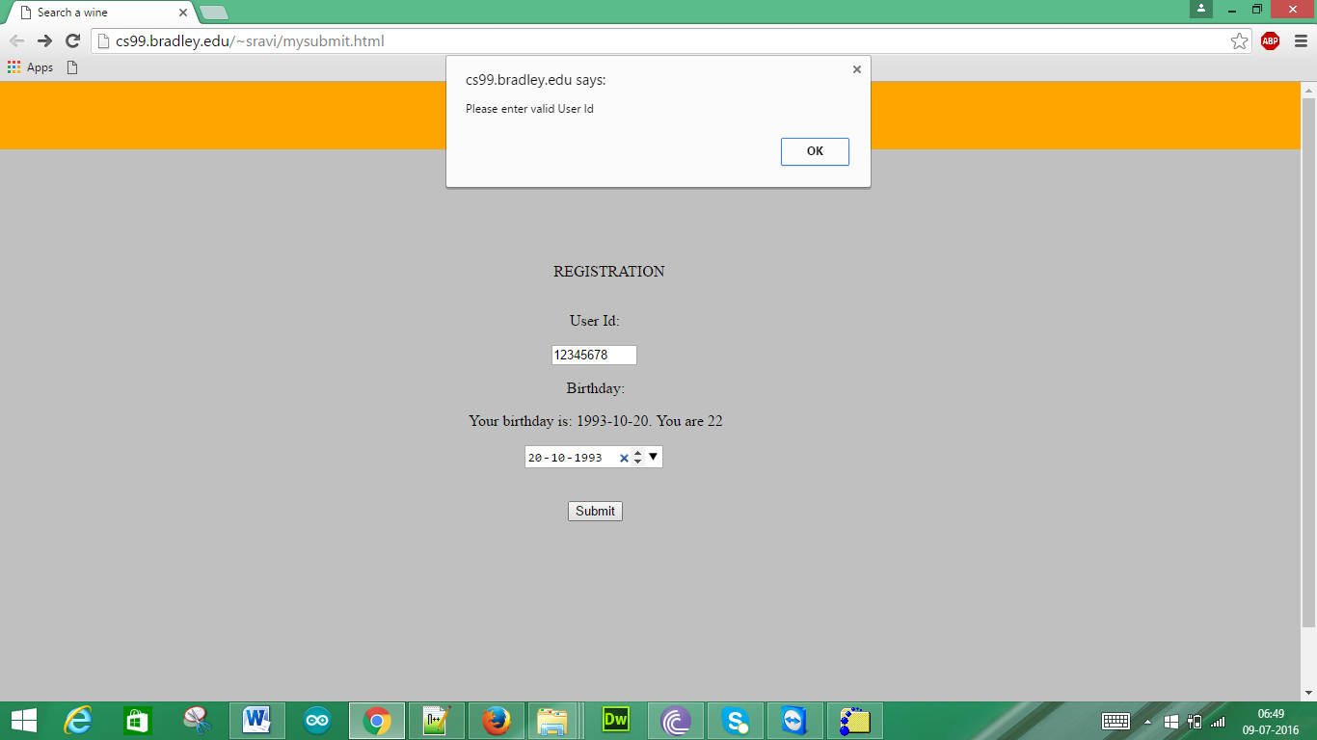

When we click OK we get

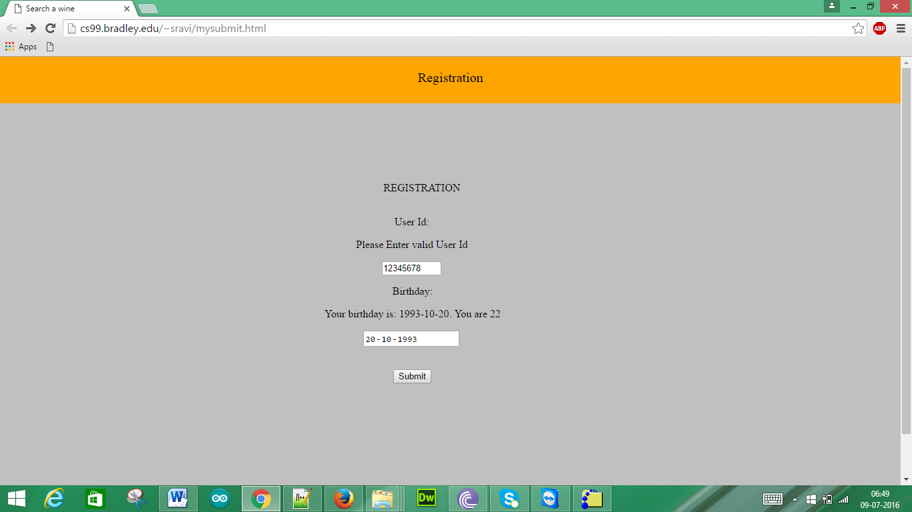

When input is as follows:

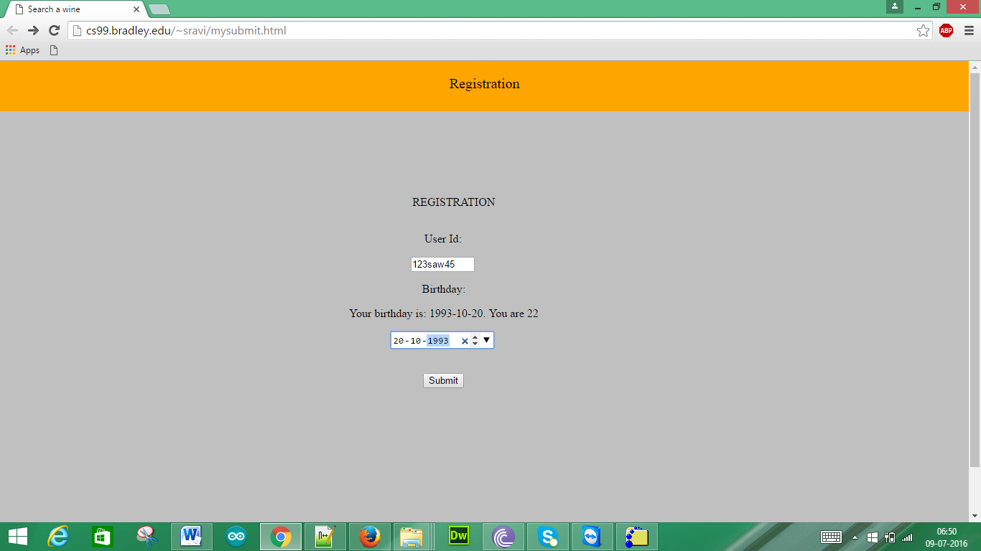

We get as follows:

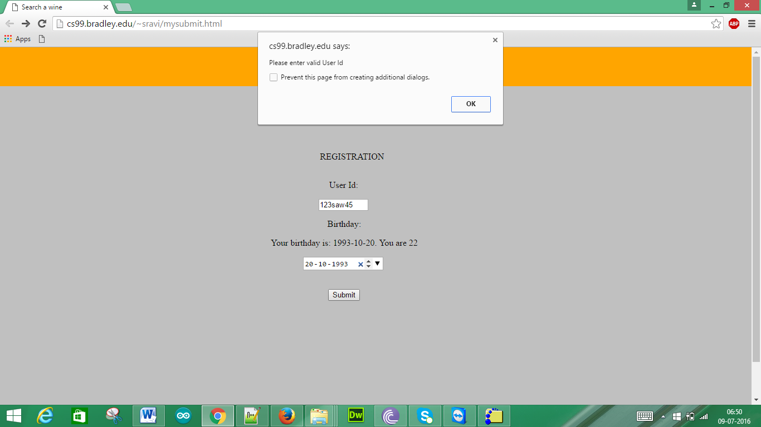

When we click OK we get as such

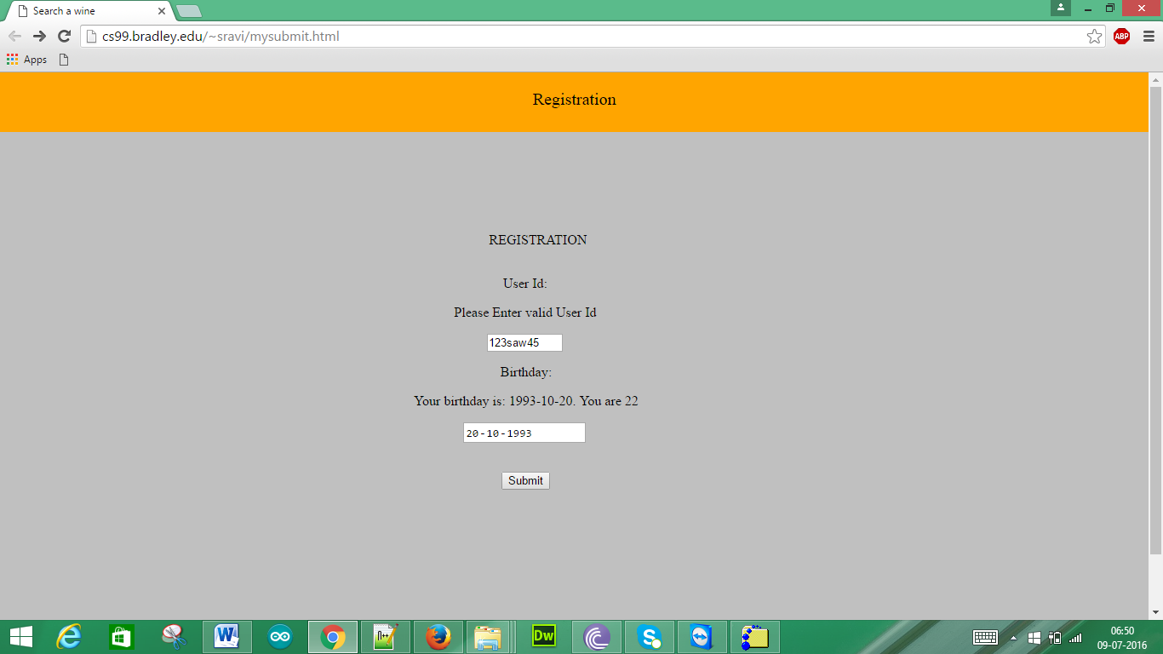

When we give input as such

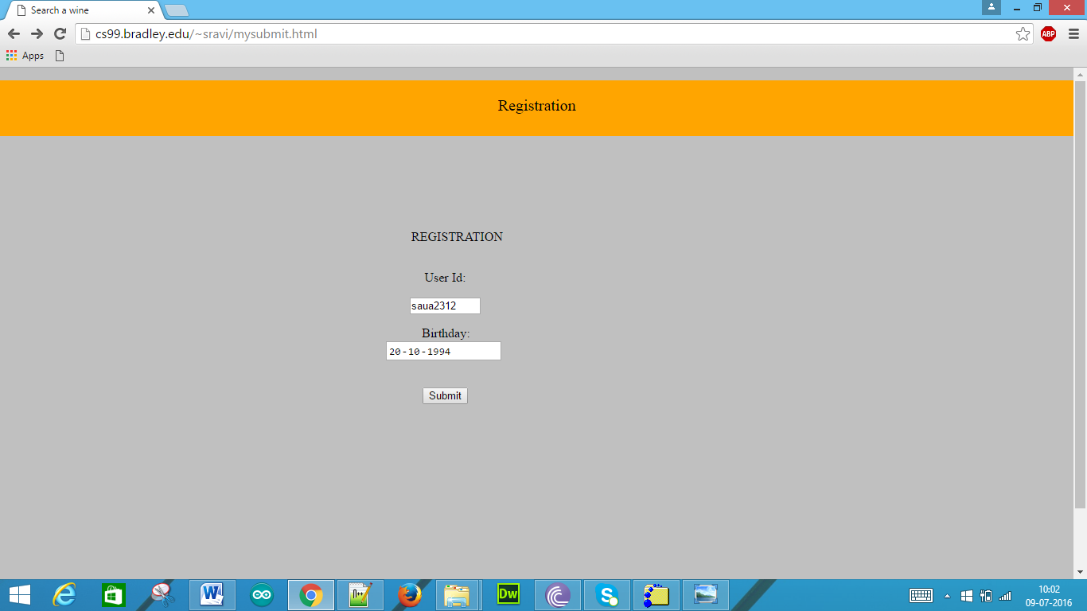

When we click the submit button we get the following pop up

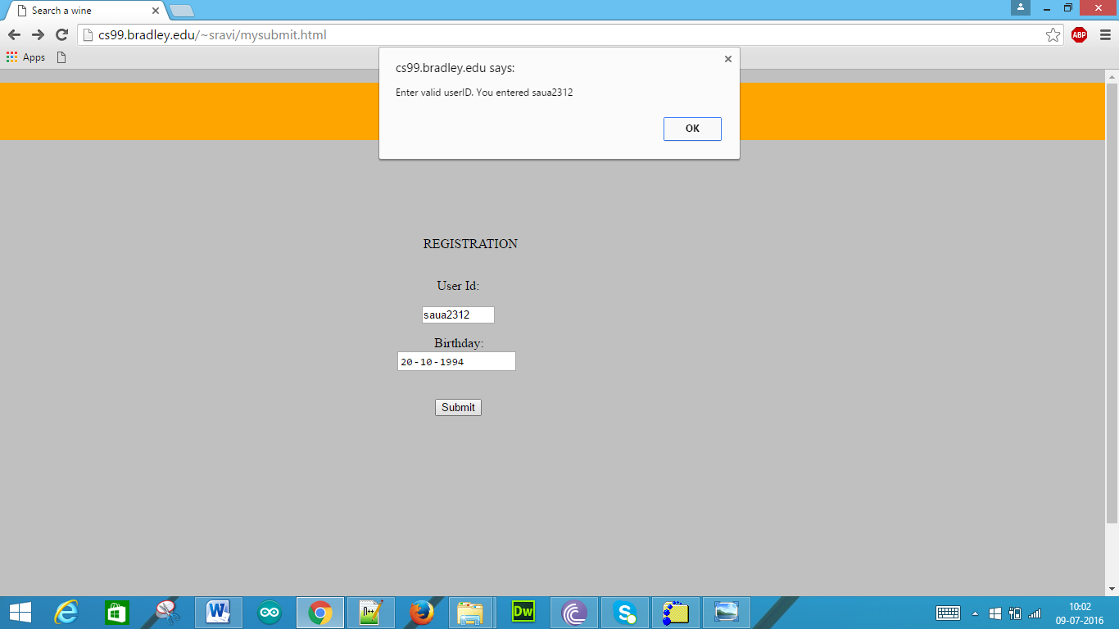

When we click OK we get as following:

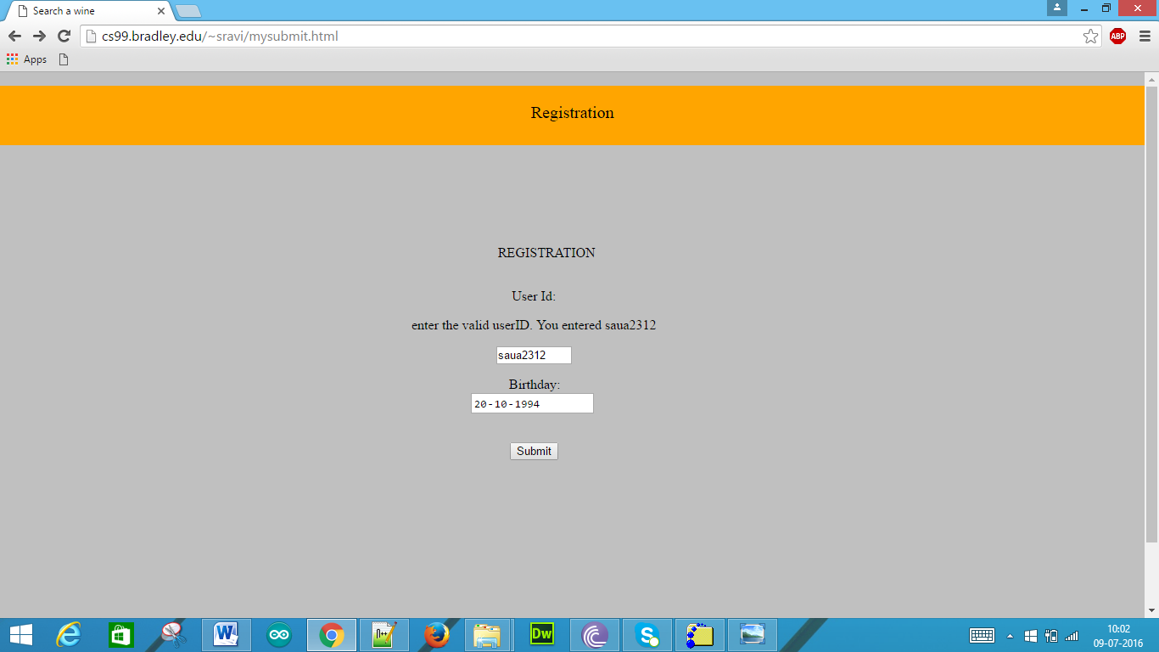

This kind of output is because of the Javascript object.

4. (30 pts) Web programming using PHP

a) Write a web page that submits a wine price and a wine year to the winestore database using wines.php. The GUI form should include a text field for the wine price, a drop down list for the wine year, and a submit button.

Sol:

Firstly we need to create a PHP file using the Notepad++ which is as follows:



PHP script for the web page is as follows:

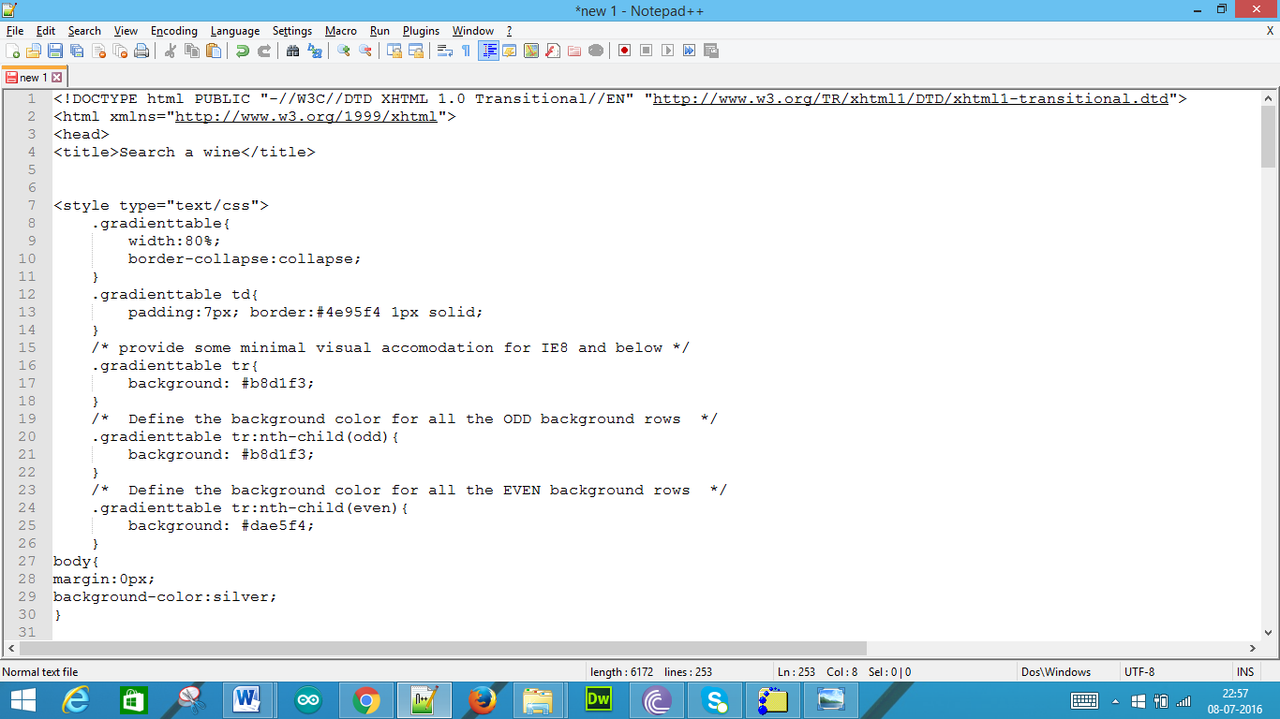

Now we save that file as **wines.php**

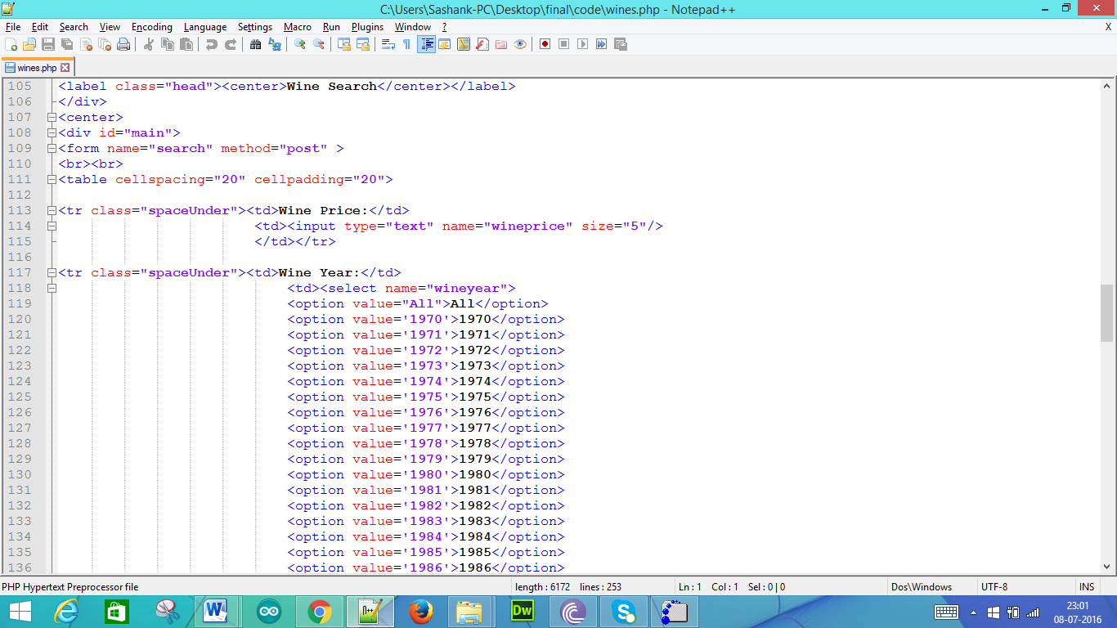

CSS code for the above designed web page is as follows:

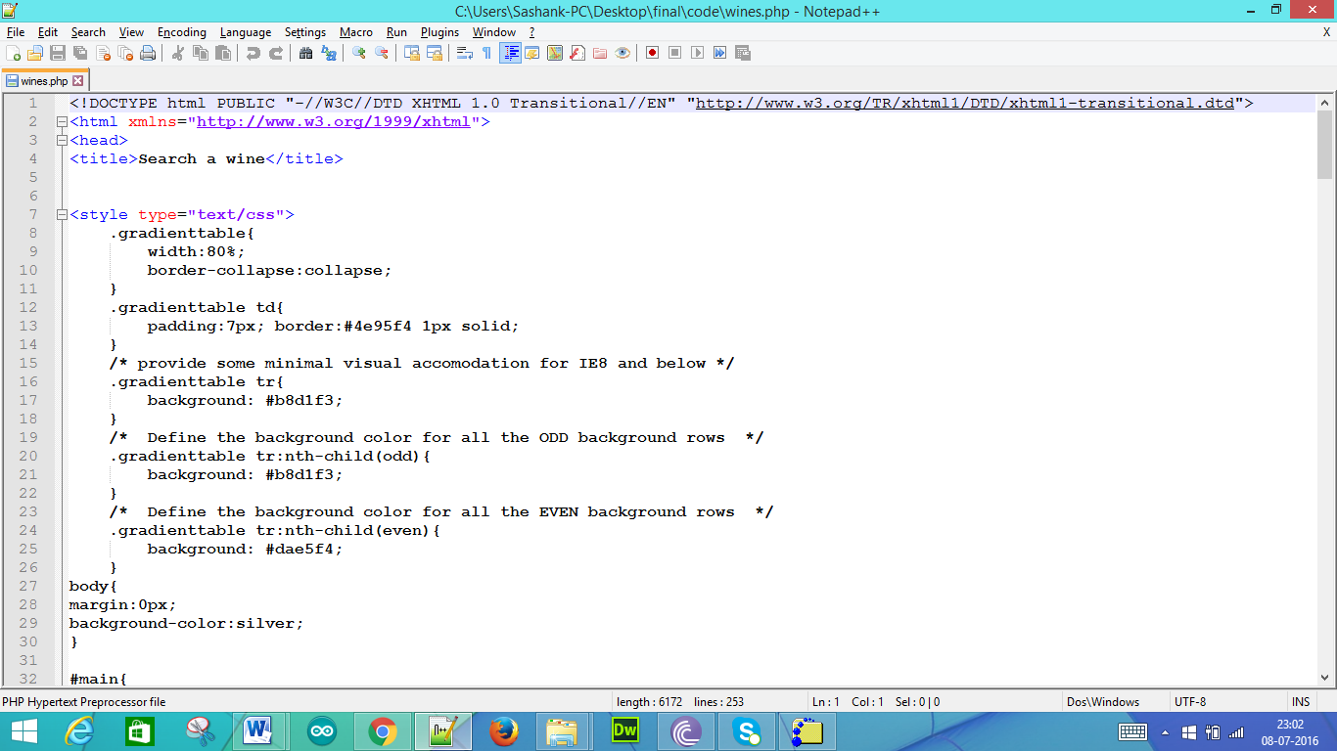

This is tag for the Wine Price

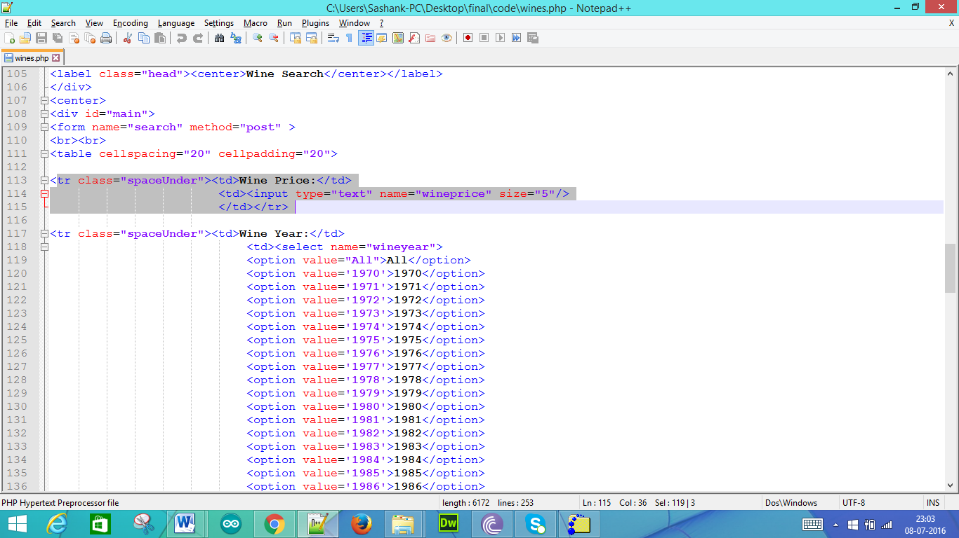

This is tag for the Wine Year

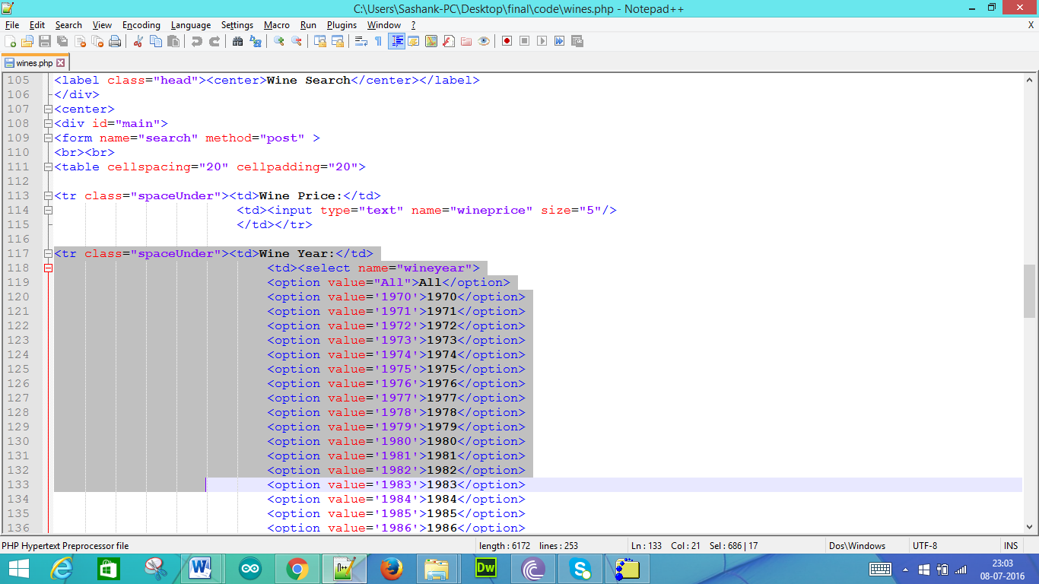

This is tag for the submit button

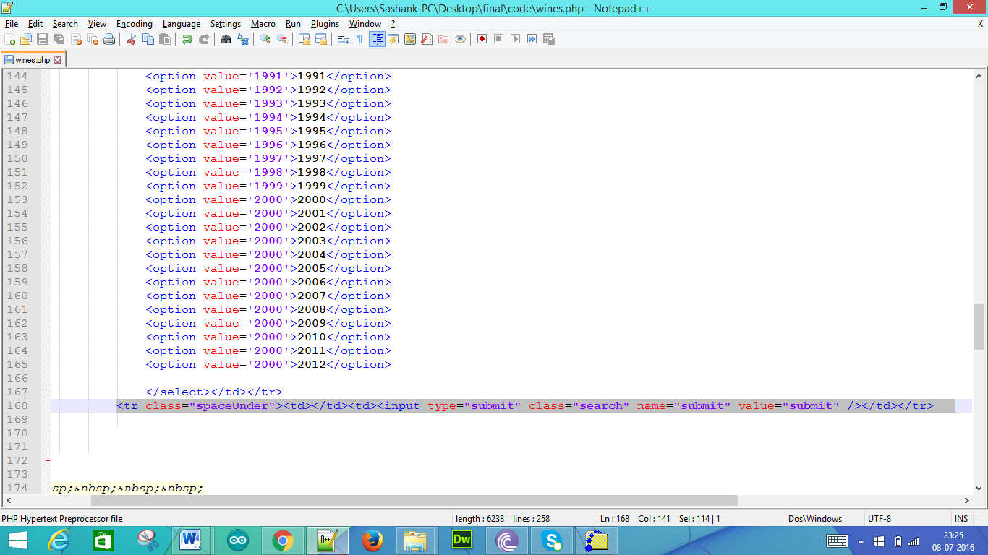

As we have connected for the server before we have to just upload the file wines,php

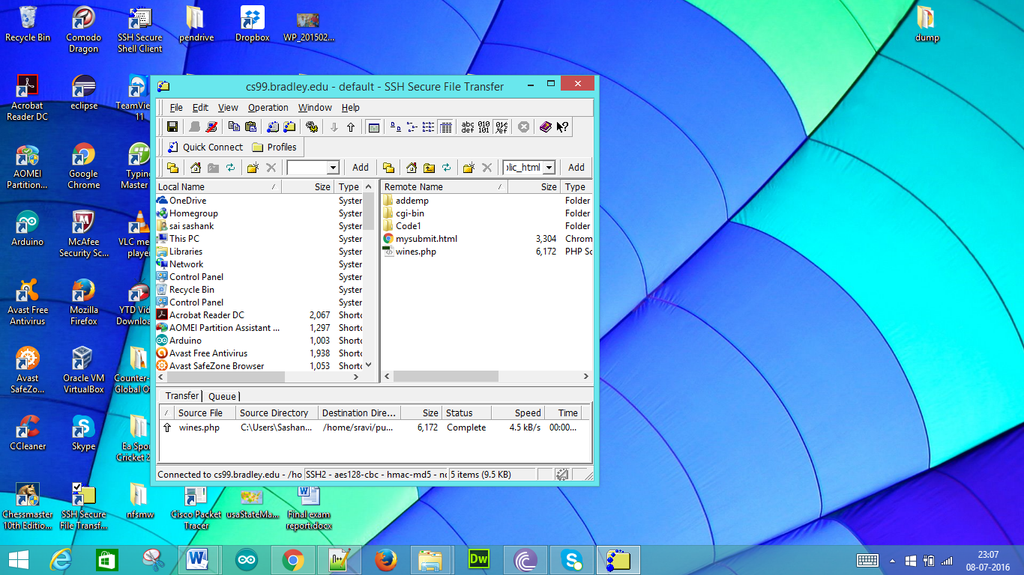

In the browser we can access the file using following URL: <http://cs99.bradley.edu/~sravi/wines.php> . We get as follows:

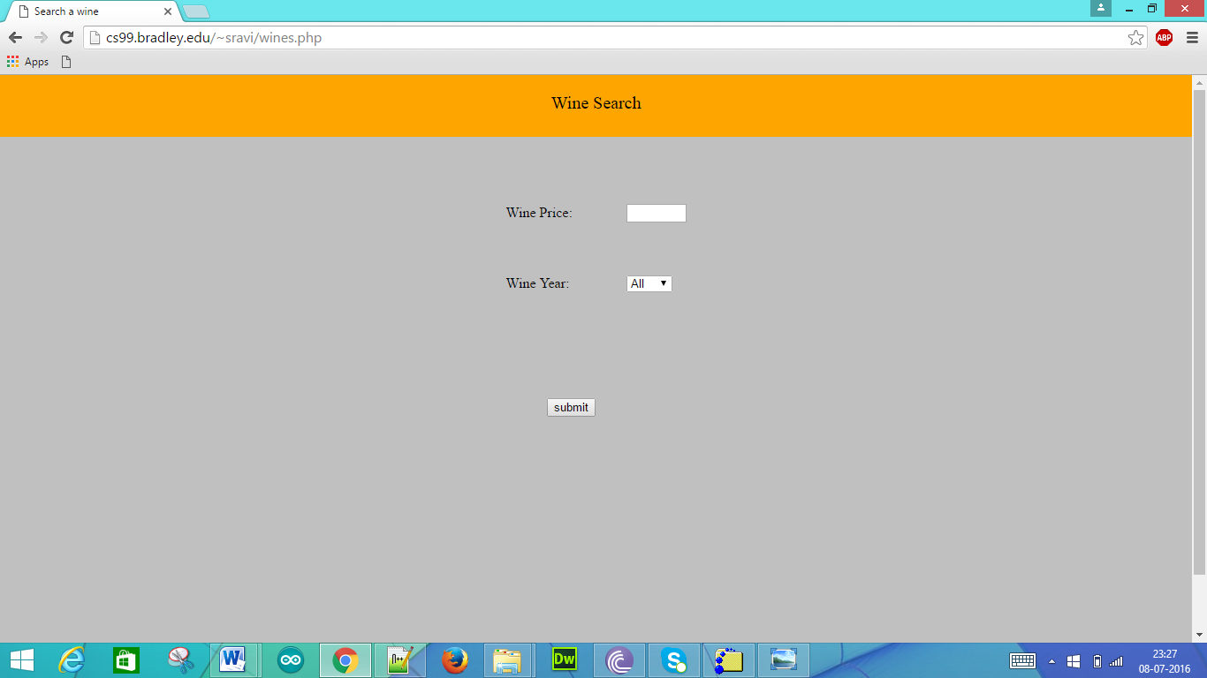

The drop down list is as follows:

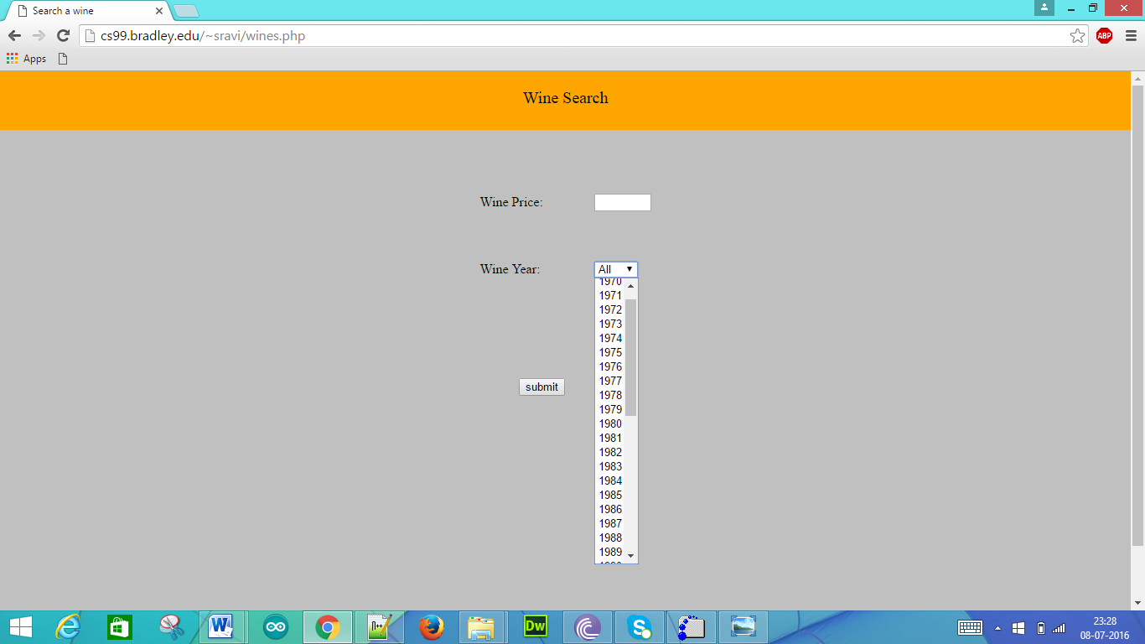

The page has the text field for the wine price, drop down list for the wine year and the submit button.

b) Write the wines.php that queries the MySQL winestore database as in the assignment 3. The wines.php will return all the wine information with the wine year specified and the wine prince less than the price specified if the query is successful, or a “Not Found” message if no entry was found.

Sol:

The database that has been created in the Assignment 3 is as follows:

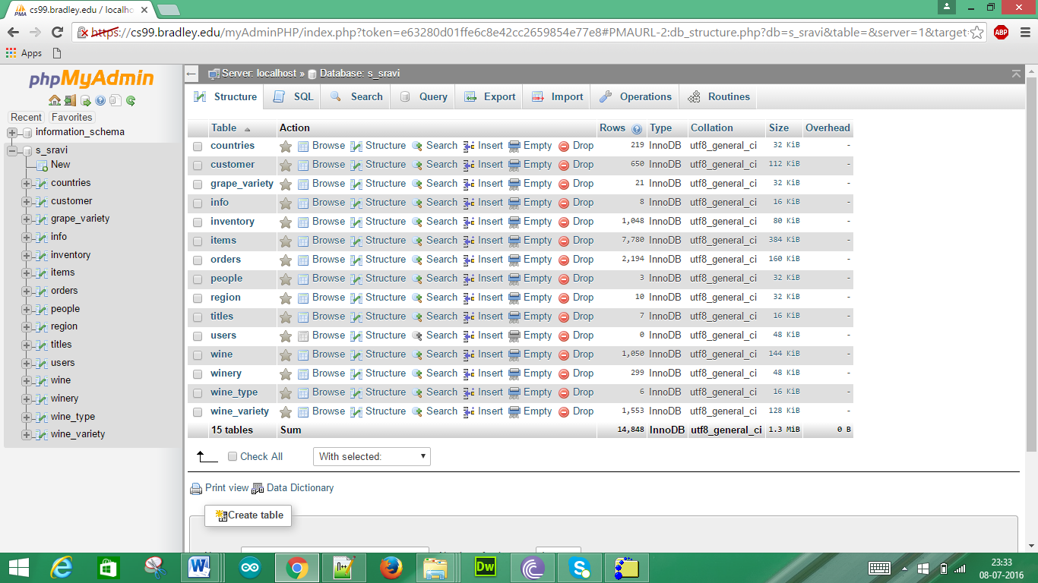

This is the connectivity for the database

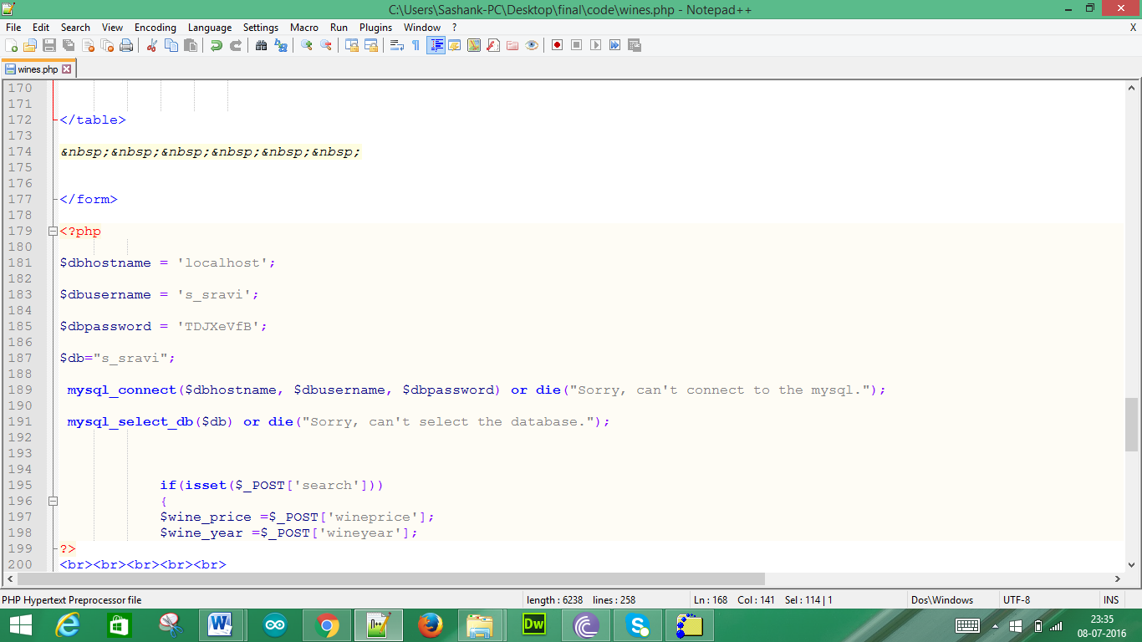

Wines.php file will have the code for the queries

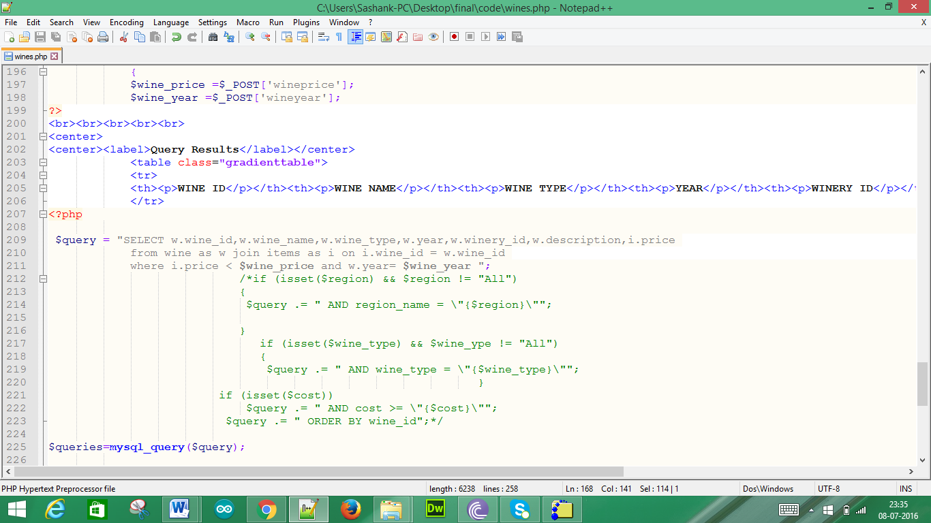

If the database consists of the requested inputs the following will be presented as output

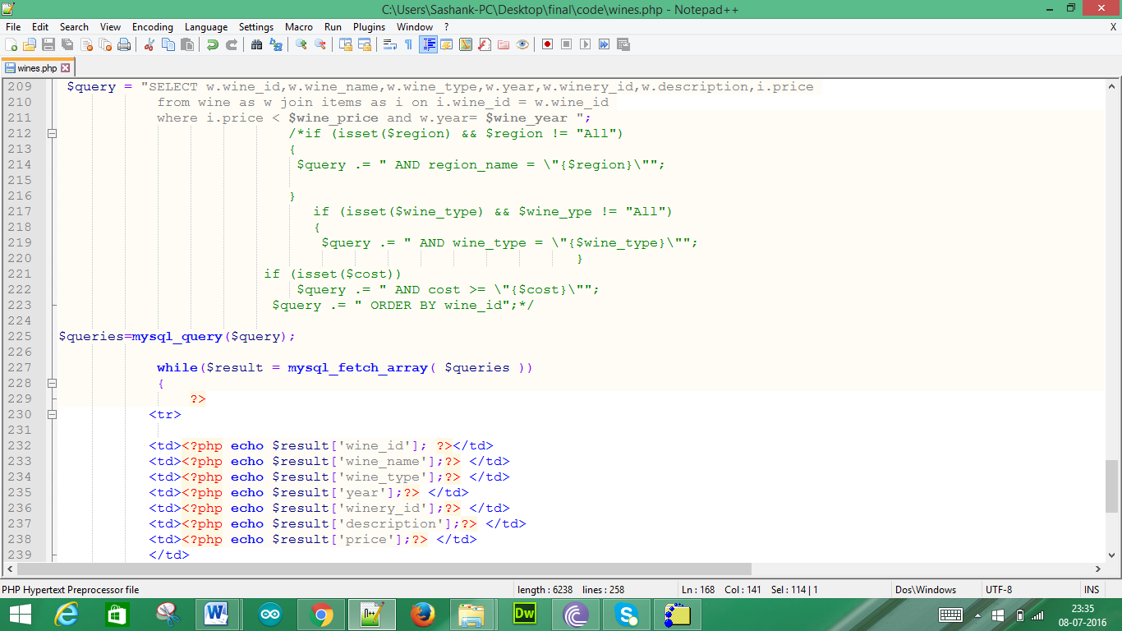

If the database does not consists of the requested inputs then we get “Not Found”

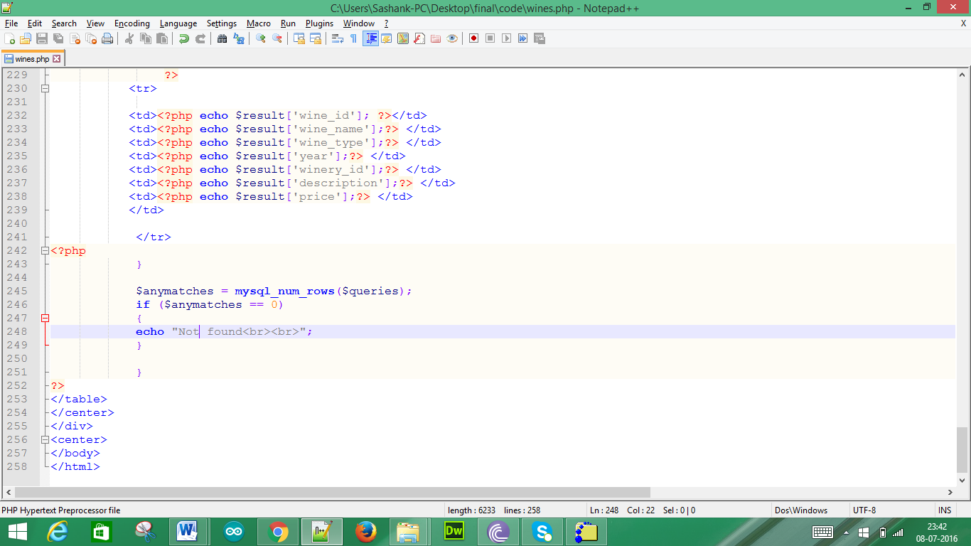

c) Test and run the above web page and PHP program; submit the source code and run results with both successful and unsuccessful queries.

Sol:

With the URL mentioned above we get the following page

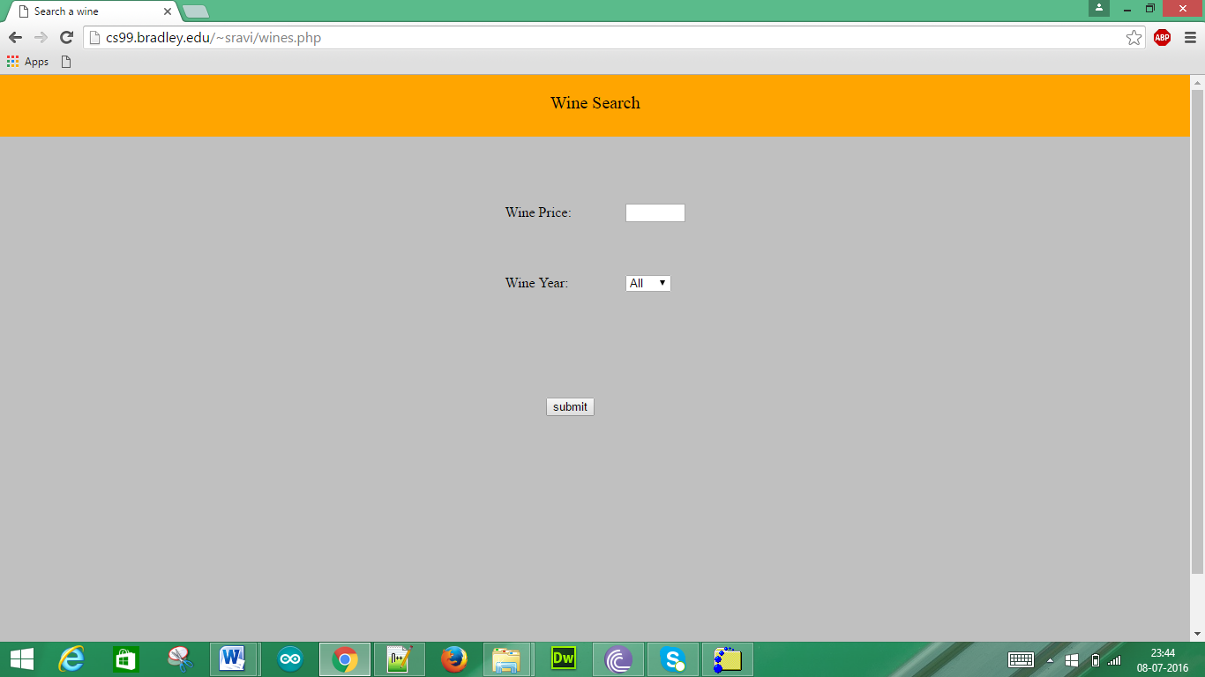

When we enter the Wine price as 10 and Wine year as 1985

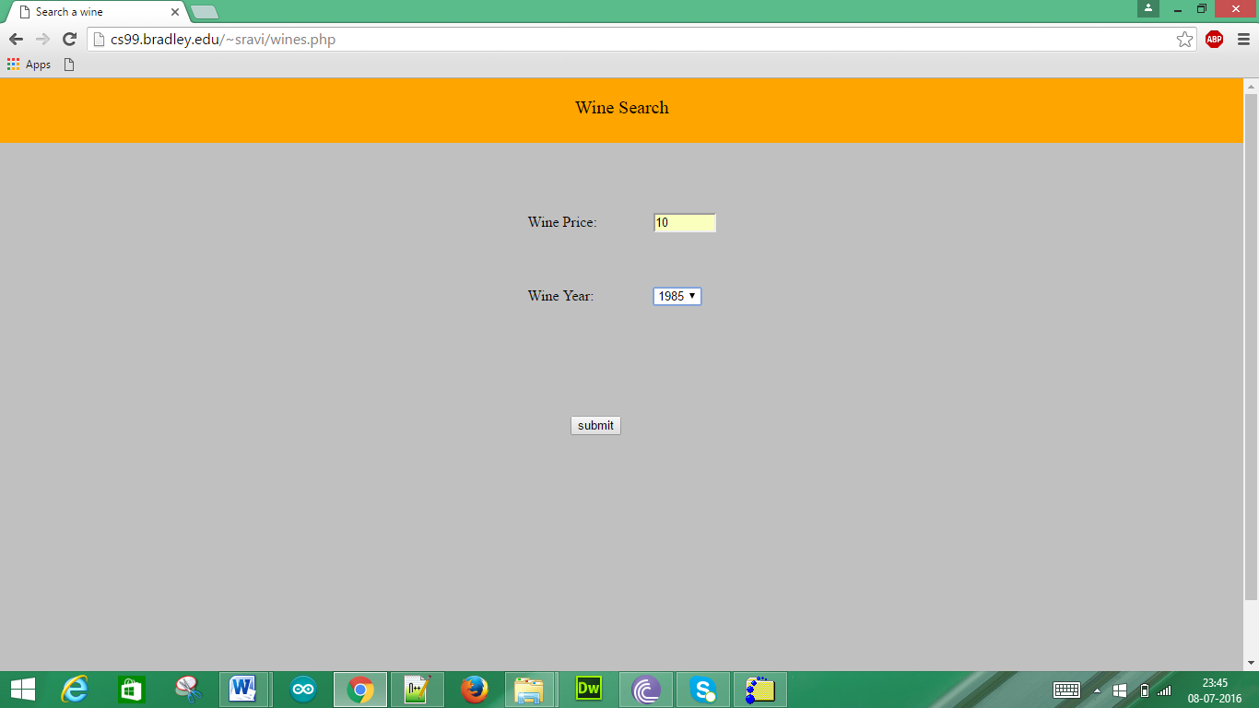

We get the wine information which is less than the wine price 10 when we click submit as follows:

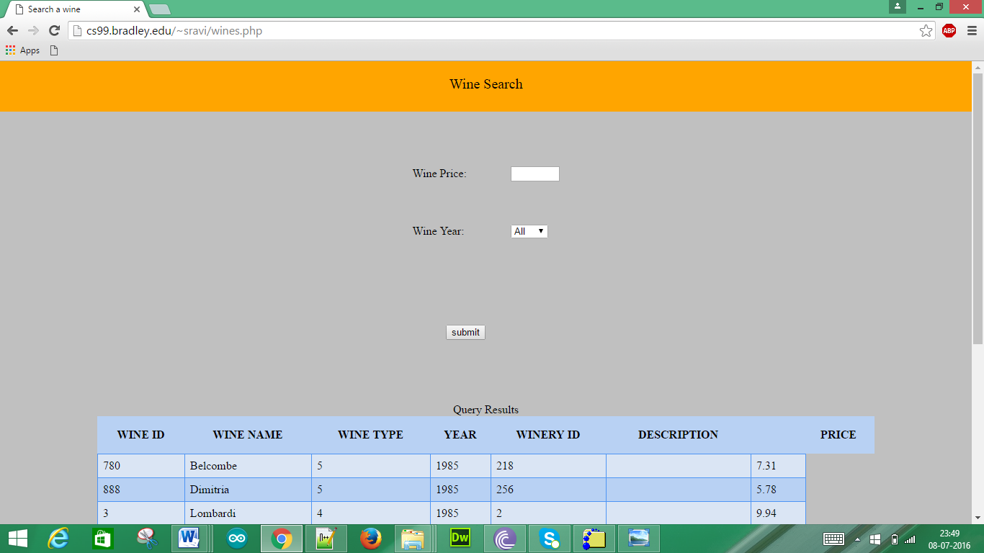

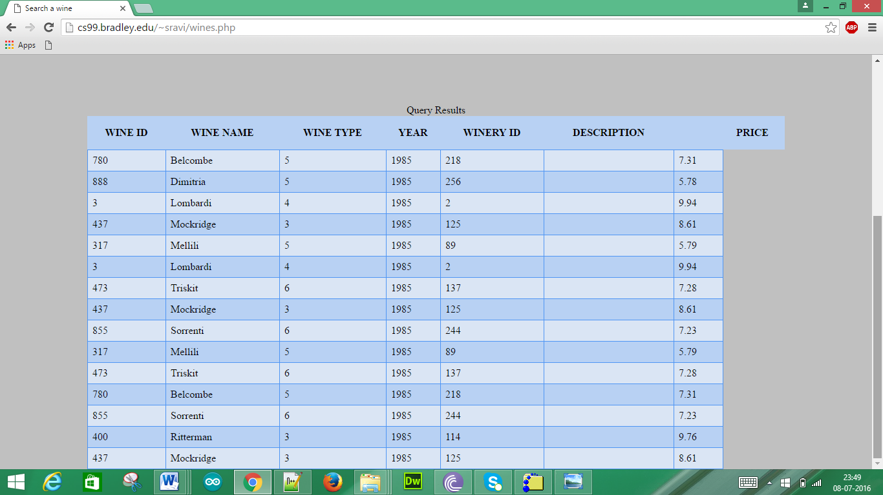

When we enter the Wine price as 14 and Wine year as 2008

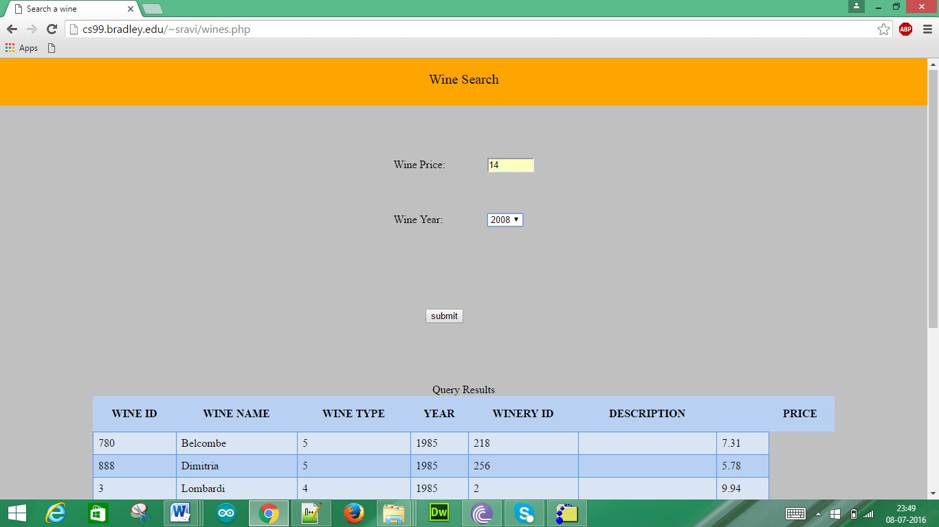

We get the wine information which is less than the wine price 14 when we click submit as follows:

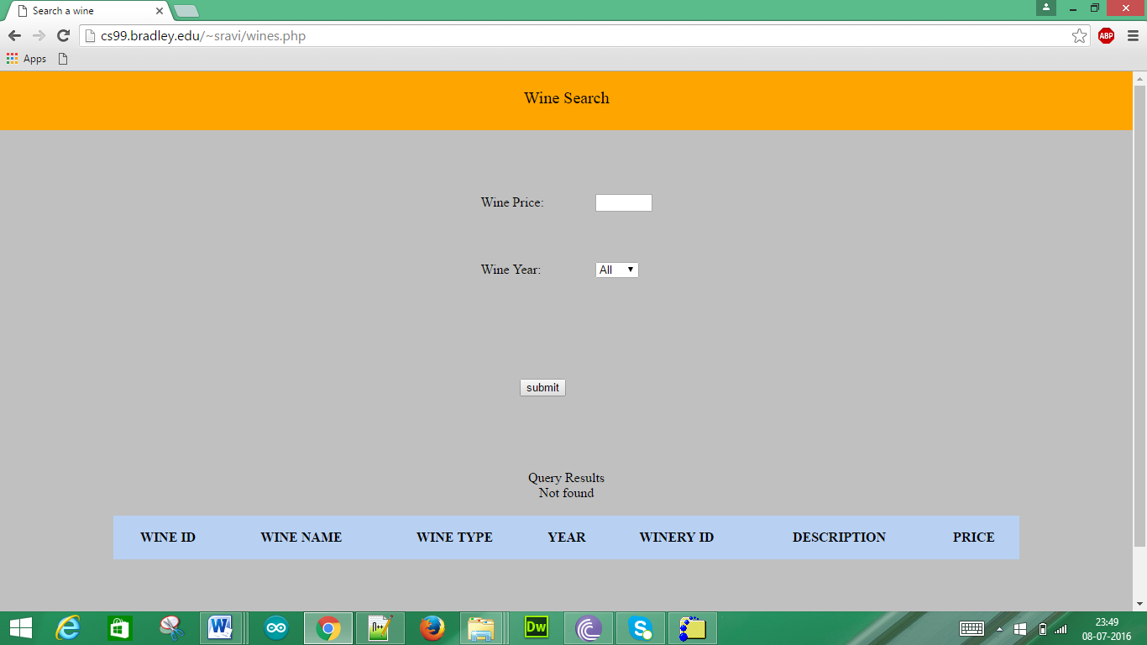

This is because the database does not have the data as per our required inputs.

5. (10 pts) AJAX

a) What is the main advantage of using XML and JSON in AJAX to pass the data object between the web server and the client?

Sol:

**XML:**

One of the most important advantage is that XML containing a safe structure of data and it is very important to send and receive. The other important thing is its speed during reading and writing. And the other important parameter is that its tags will defend the data from sniffers and hackers during transferring.

Two methods of XMLHttpRequest are used:  
- **open**: command GET or POST, URL of the document, true for asynchronous.  
- **send**: with POST only, the data to send to the server.

**JSON:**

The most important advantage is that JSON circumvents JavaScript's same-source policy, if you import the JSON file as a new <script> tag. JavaScript does not allow you to access documents (be they XML or HTML) that come from another server. However, if you import a JSON file as a script tag you circumvent this problem, and any JSON data can be imported into any website. It depends on your business goals whether this is a Good or a Bad Thing, but right now it's the only data format that allows unrestricted access.

A secondary advantage is that scripts for JSON data are slightly simpler and slightly more in line with the rest of the JavaScript language than scripts for XML data.

1. Describe one main advantage of using AJAX in Rich web computing applications as compare with the traditional web computing application without using the AJAX?

Sol:

**Enhanced User Interface:**

Ajax improvers the user experience by making interactive web applications more responsive. Entries are validated individually, dynamically as the user enters data into the fields. If a problem is found, the server sends an error message that is asynchronously displayed to inform the user of the problem.

Where as in traditional web computing it requires a total page refresh in order to fetch the data for a portion of section in the page. But in Ajax we can perform multitasking without refreshing the page.

**Advantage:**

By using a client side technology which can execute instructions on the client's computer, RIAs circumvent this slow loop. This difference is somewhat analogous to the difference between "terminal and mainframe" and Client-server/Fat client approaches. It should be noted that Internet standards have evolved slowly and continually over time to accommodate these techniques, so it is hard to draw a strict line between what constitutes an RIA and what does not.